**ANGULAR 13 course**

**Note :-**

* 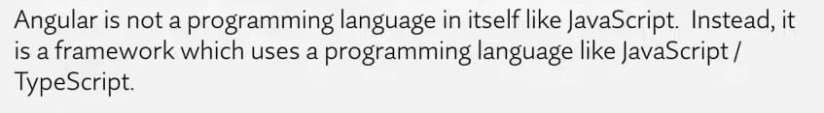
* Angular is a JS framework which allows us to create Single page aplications. A framework is like a platform for developing software applications. A framework has predefined classes used to process input, manage hardware and interact with system software.
* SPA => which has only one html file. Ex- gmail
* In SPA, the page never changes only the content of the page changes
* Advantages of SPA –

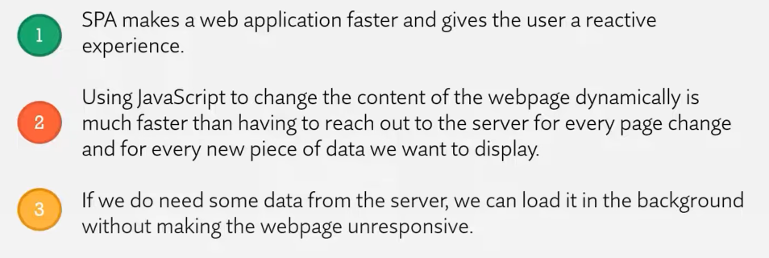

* We can use JS/Juery to make SPA but the code becomes hard to maintain and testing become difficult.
* Why to use Angular ?

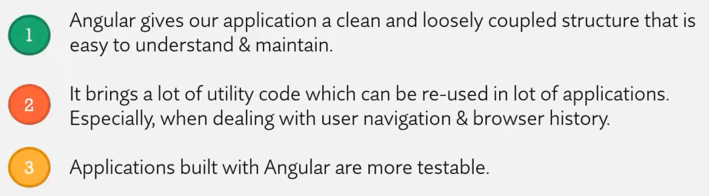

Node.js => runtime environment for executing javascript code outside of the browser environment.  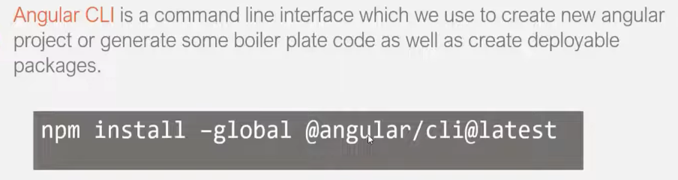

* 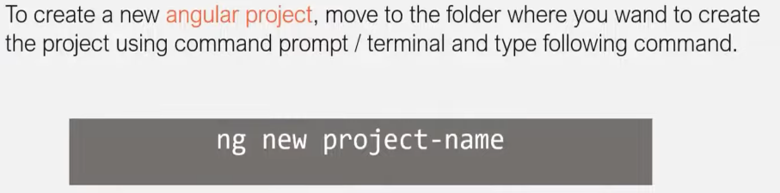
* 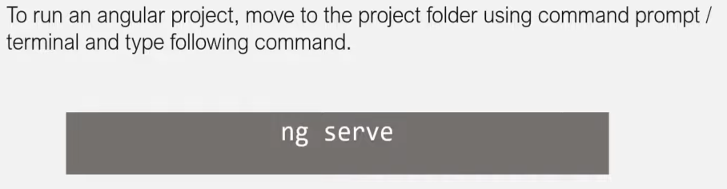
* **How Angular app works** –

1. Src folder contain all the angular related code
2. Angular allow us to mix static html code with dynamic content we want to output in that code

Ex - <h1>Welcome to {{title}}</h1>

The value of title comes from app.component.ts where we have a class called AppComponent.

This class has a title property which is assigned with the value “AngularBasics”

So Angular will replace the value of this title property when we render the app.component.html in browser. This feature of angular is called data binding.

1. App.component.css, app.component.html, app.component.spec.ts, app.component.ts

These 4 files together makes the app component. It is by default provided by angular CLI

1. **app.component.ts** => it is the main component file

**app.component.html** => it is html file of app component

html file of a component is also called its **view template**

**app.component.css** => here we can specify css for app.component.html

**app.component.spec.ts** => it has code for testing the component

1. Inside app.component.ts there is @Component decorator on AppComponent class. We passed an anonymous object inside the decorator which has property selector which is assigned value ‘app-root’

Now this value can be used as an html tag

1. It is the index.file which is rendered in browser when we run angular app.

**<app-root></app-root>** is replaced by the content of app.component.html file that’s because for selector we have also defined **templateUrl** which is assgined to the path of app.component.html file

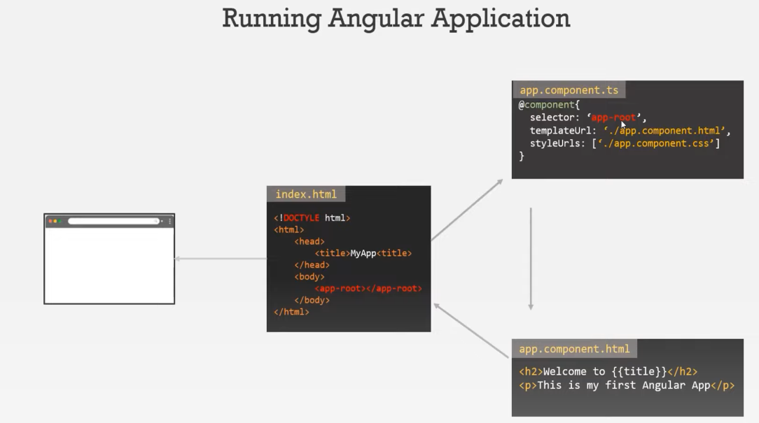

1. **Angular files and folder structure**
2. **Node_modules =>** here all the 3rd party libraries are stored on which our might app depends. It is only for dev purpose not for deploying at production.
3. **Src folder =>** all code related to angular app
4. **App folder =>** by default it has one component and one module

Every new component, service or module is created inside this app folder

(every angular app must have one component and one module)

1. **Assets** => in this we store all static assets of our app like images, icons etc
2. **Environments =>** used to setup different evn. Inside it has 2 files - one for production and for development env. where we can write some configurations like db credentials or sever ip addresses
3. **Favicon.ico** => icon file that displays on browser
4. **Index.html** => main html file which renders on browser when app run

Inside it we don’t have any reference to css or js file because all these dependencies will be injected to this file during the build process by angular cli

1. **Main.ts** => it is starting point of angular app. First file to be executed. It is like main function for other languages.

In this file, we are bootstrapping the main module to this project and the main module is AppModule

So when we run our app, angular will load AppModule and everything else will start from there.

1. **Polyfills.ts** => it basically imports some scripts that are required for running angular. This is required as angular uses some features of JS that are not available in the current versions of Js supported by most browser available out there.

So this polyfills fill the gap between features of Js that angular needs and the features supported by current browser.

1. **Styles.css** => here we define global styles, also each component can have its own style
2. **Test.ts =>** used for setting our testing environment
3. **.editorconfig =>** requried to setup team env., some standard rules defined
4. **.gitignore =>** specify files which are not included in git repo
5. **Angular.json =>** contain all configurations of angular project like path for main.ts, index.html etc.
6. **Karma.config.js =>** configurations for karma which is test runner for JS
7. **Package.json =>** standard config. file which every node project has. It also has list of dependencies
8. **ts.config.json** => it has bunch of settings for typescript compiler
9. **How Angular project is executed** –
10. First file which executed is main.ts, here we bootstrap the main module which is AppModule
11. Inside app.module.ts we have a bootstrap array which lists all the components which should be known to angular at point of time it analyzes index.html file.
12. Now Angular will analyse the AppComponent in app.component.ts file and will read the configurations which is specified for this. We have decorated it will @Component decorator and this decorator has selector property with value ‘app-root’
13. Then index.html file will be loaded in browser and app-root will be replaced by html content of view template of app component

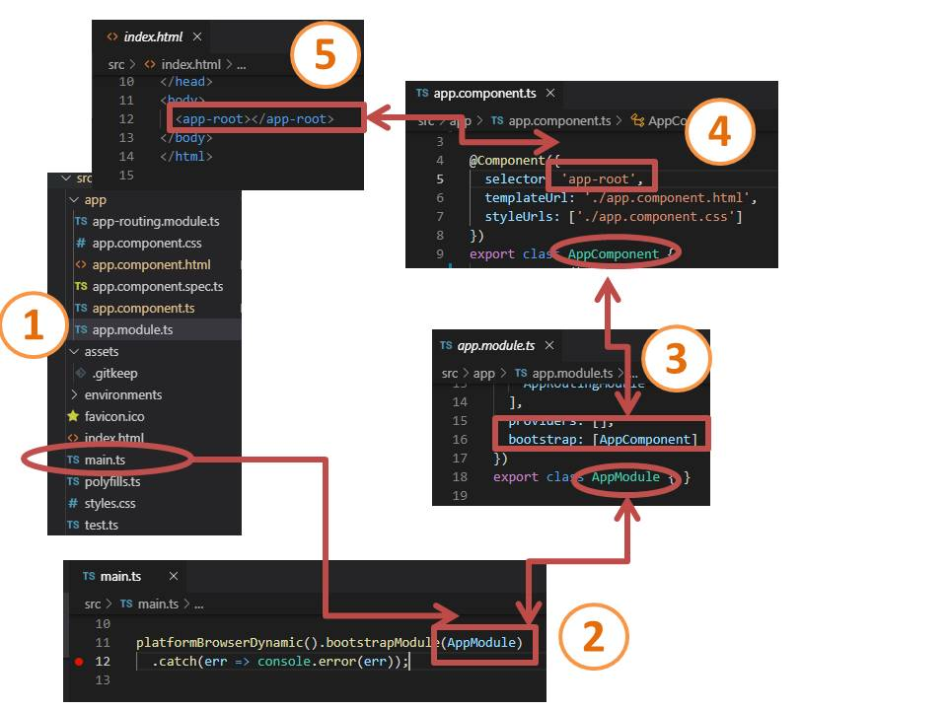

* Ng serve command first rebuilds the project then it will create js bundles and it will add then to index.html file.
* 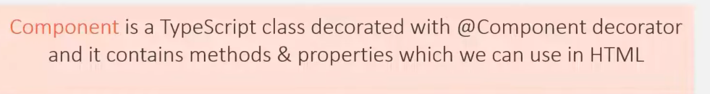

Main component of app is AppComponent it is also called root component. It can have listed other components.

* In application, we can have a component for header, navigation bar, for each menu in navigation bar, for main content area and side bar, and a separate component for footer. Combining all these components and nesting it with the root component will create our angular app
* 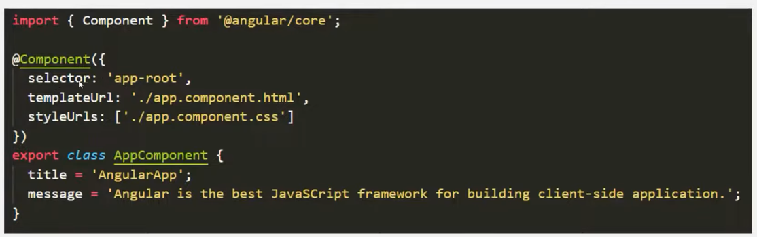
* Inside decorator we pass anonymous object which has several properties

**styleUrls** => this is an array inside which we can specify path to several css files and those styles will be applies to the view template of that component.

**templateUrl** => location of view template

* Inside AppComponent class we can have properties and methods. We can use them inside html file / view template of that component.
* 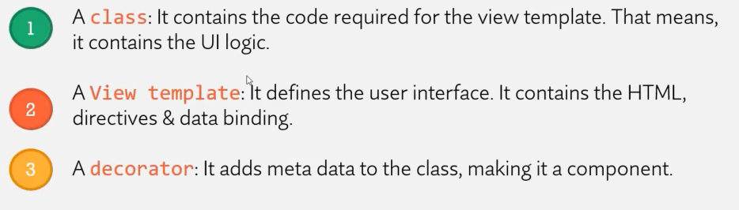
* Inorder to use a component, we also need to export the component class and register it in app.module.ts file in its **declarations** array.
* To create a component => ng g c <its_name>

Or ng generate component <its_name>

To create a directive => ng g d <its_name>

* **template** property => we provide html code inside a string

For multiple line use back ticks ` `

Template property is not recommended as u don’t get error by vscode on misspelling tags, secondly we are mixing html with typescript.

* **Styles** property => its an array and we write inline css

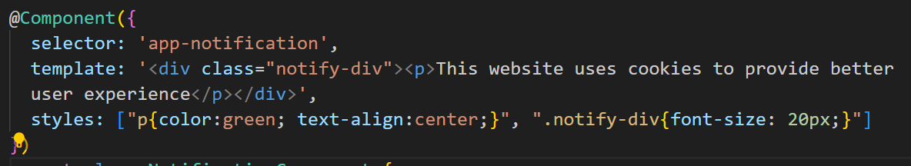

* **Types of Selector**  - working is same for all, that they display the view template in index.html

1. Using selector as attribute

selector: '[app-nav]',

<div app-nav></div>

1. Using as a css class

selector: '.app-nav',

<div class="app-nav"></div>

1. Using as html tag

* 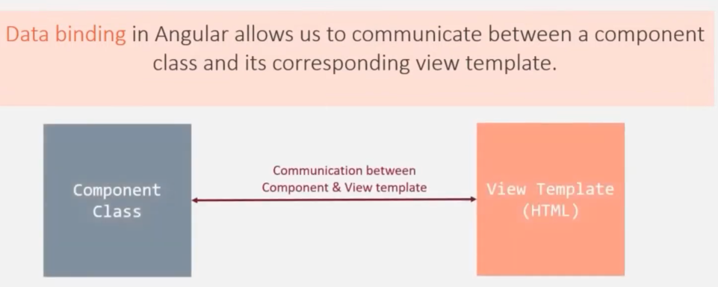
* 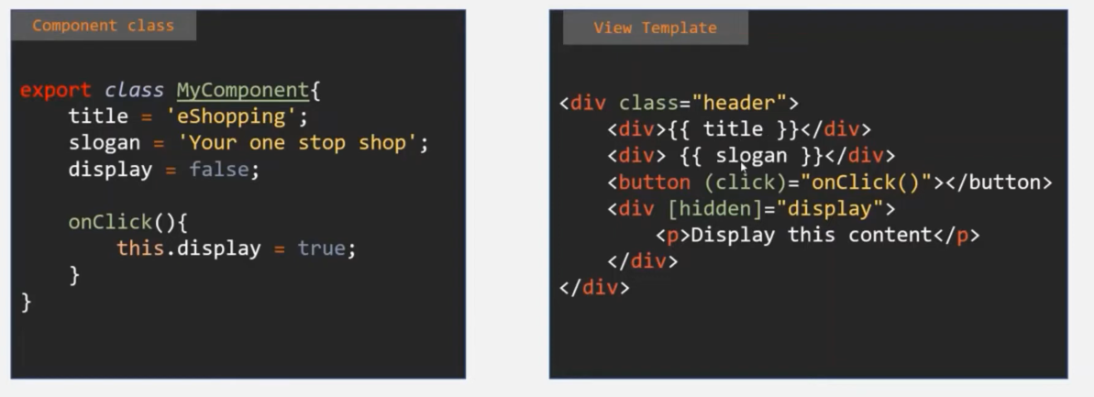
* 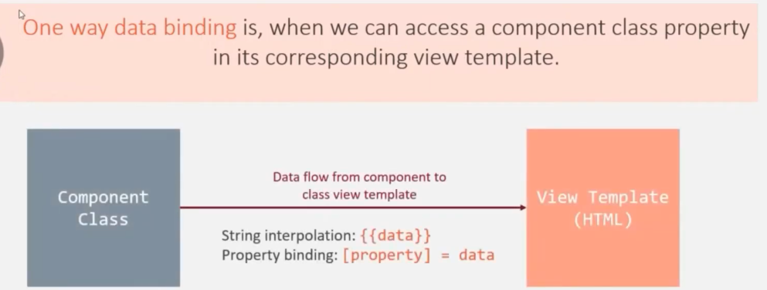
* In string interpolation {{ }} we can write any typescript expression inside

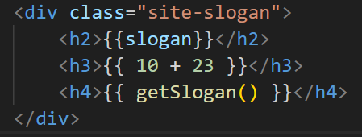

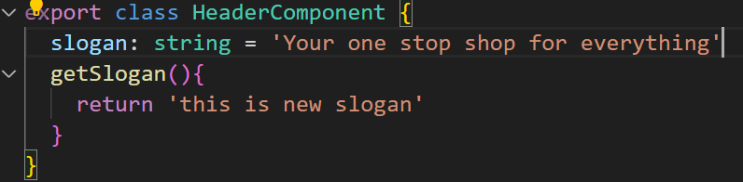

* 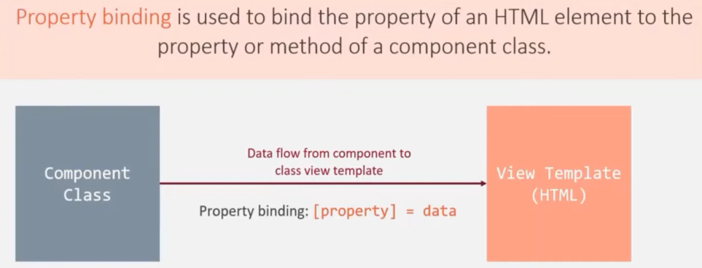

When html is rendered on web page, for each of its html element an object is created in DOM

We can bind attribute of html element/ property of DOM object to property or method of component class.

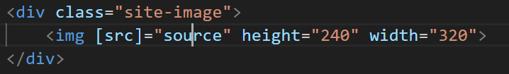 inside “ “ we can put any Ts expression

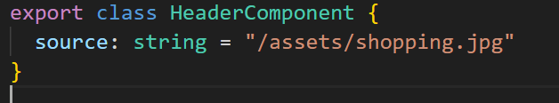

* 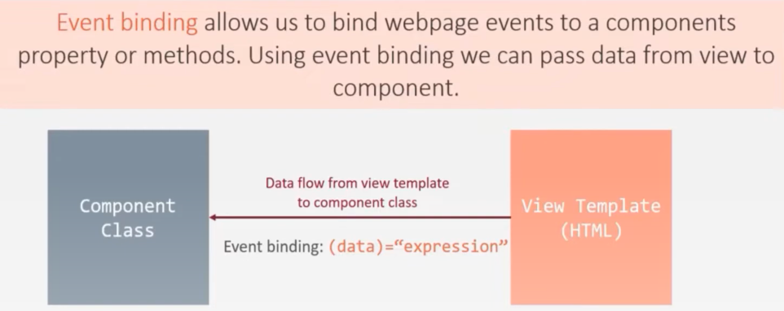

Whenever an events happens it will emit some event data related to that input event and that data will be passed to this method as its argument

Ex1 –

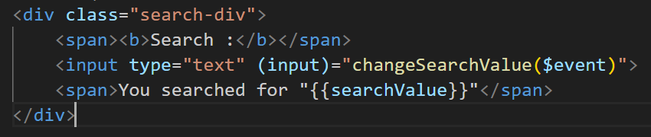

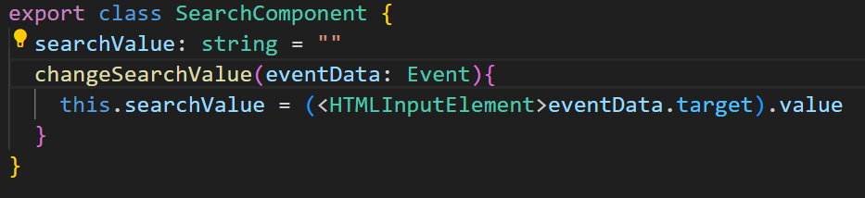

Ex2 – passing event in method is optional

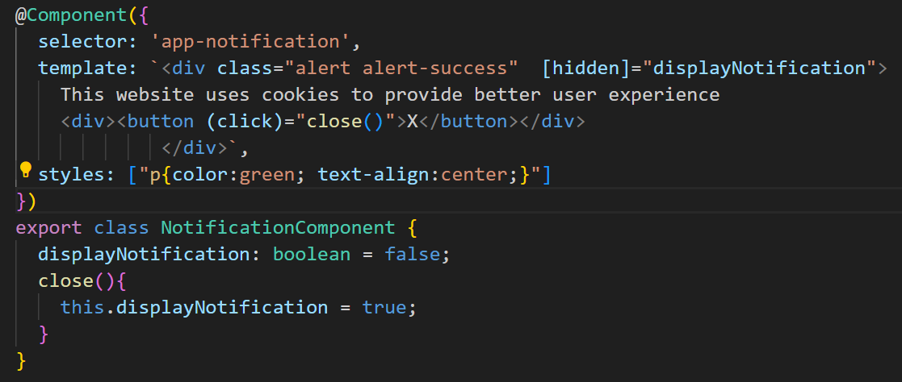

* 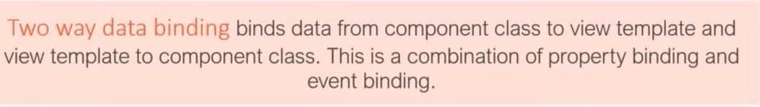

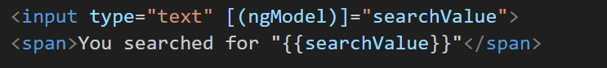

For event binding we use ( ), for property binding we use [ ]. So combine them [( )]

For using ngModel directive, we have to import FormsModule in app.module.ts

* **DIRECTIVES –** are simple an instruction to the DOM, We use directive to tell DOM what to add to the web page and what not, how to display the html element

Components are also kind of instruction. Components are directives with a template

* We can also have custom directives.

Typically we add directives with an attribute selector but technically the selector of a directive can be configured like the selector of an component.

So we can also use directive like an css class or like an html element

* Directive is also a TS class decorated with @Directive decorator

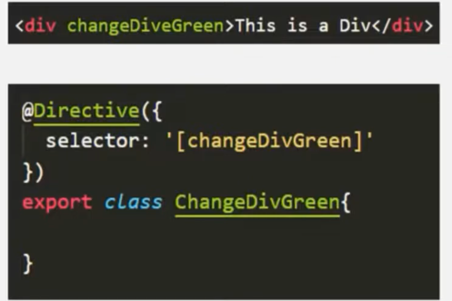

* 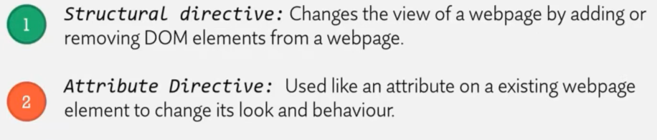
* **ngFor directive** –

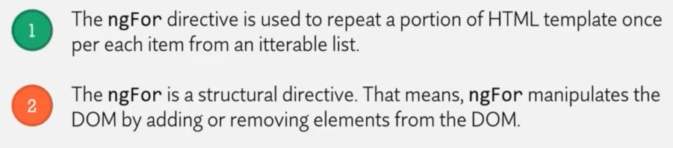

Whenever we use structural directive, we need to add * before it.

Ex-

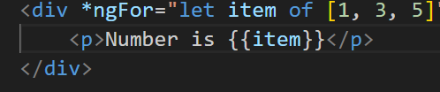

Produucts is array of object

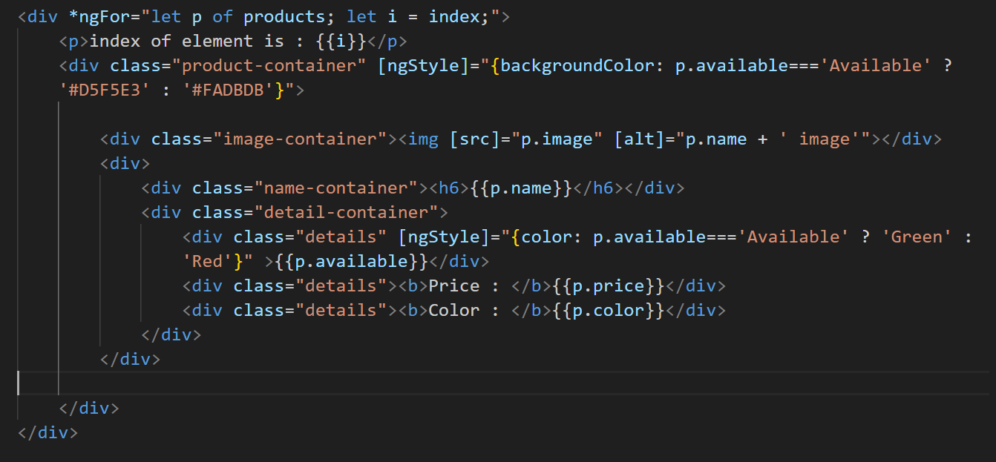

* **ngStyle directive –** basically we give an object having property-value pair, u can also just mention object name in template like <div [ngStyle]="myStyles"> and actual object present in component class

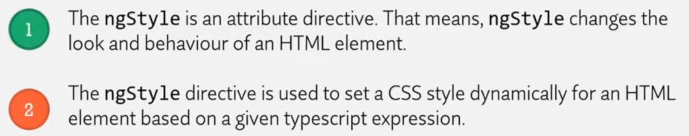

* **ngIf directive –**

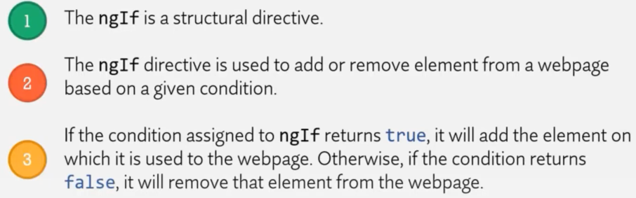

Ex-



* **ng-template –** used to create html template on web page

Ex- notifyme is name for the template which we want to display in else part

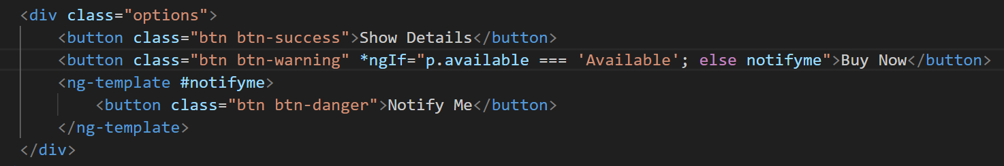

* **ngClass** –

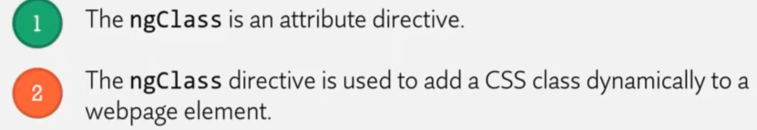

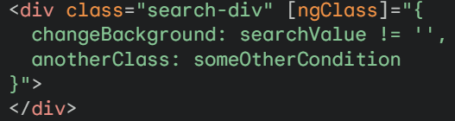

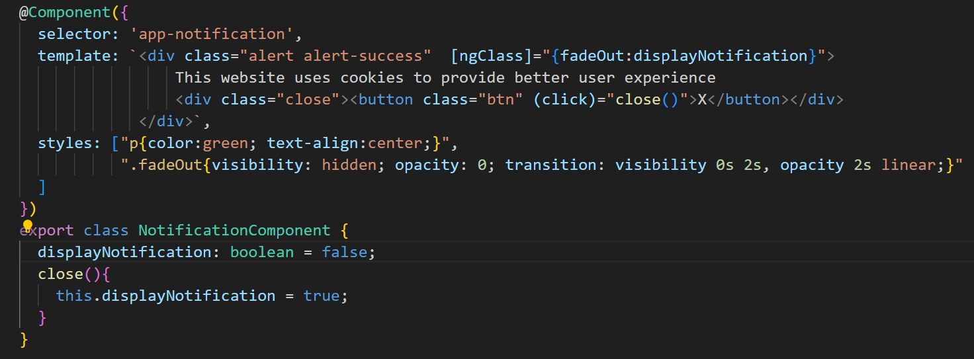

* **Child Component & Parent Component** –

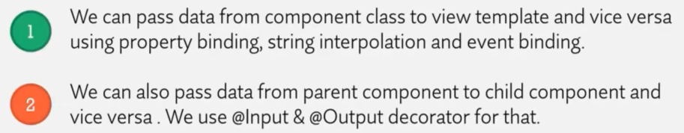

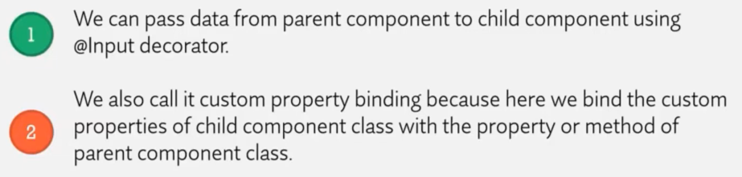

Ex – Suppose there is Course component and I want filter functionality for courses based on total, free and premium. So I create Filter component which is child component of Courses component. We have defined courses in Courses component. So we have to pass data from parent to child using @Input decorator.

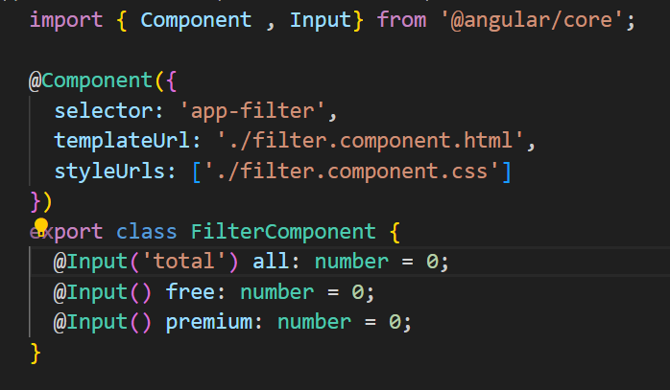

We can also provide alias for custom property of child compoent by passing into paranthesis of Input decorator.

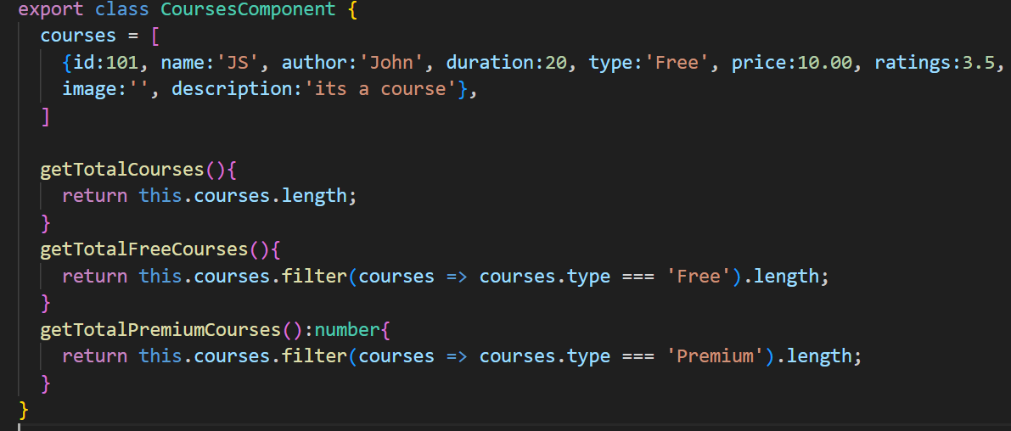

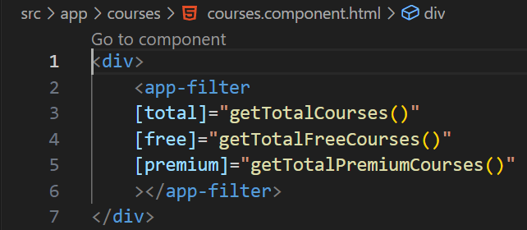

Now passing data from Filter to Course component to only display the selected courses (total / free / premium)

* To create a property an event we use event emitter class

To create a custom event –

1. First we create a property and specify its type as event emitter, and we also need to instantiate it
2. We need to decorate the property with @Output decorator

Ex-

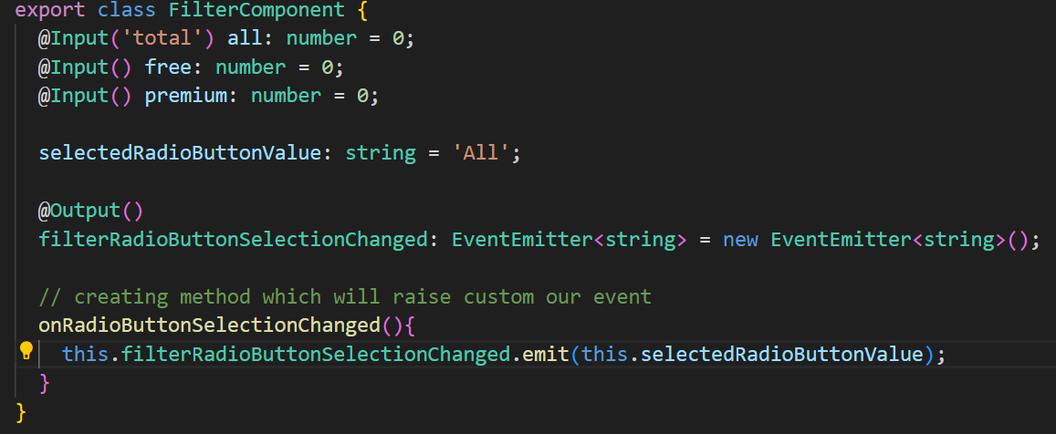

* Two way data binding will ensure that initially when pages load then out of 3 radio button having name=”filter” the one with value=”All” should be checked

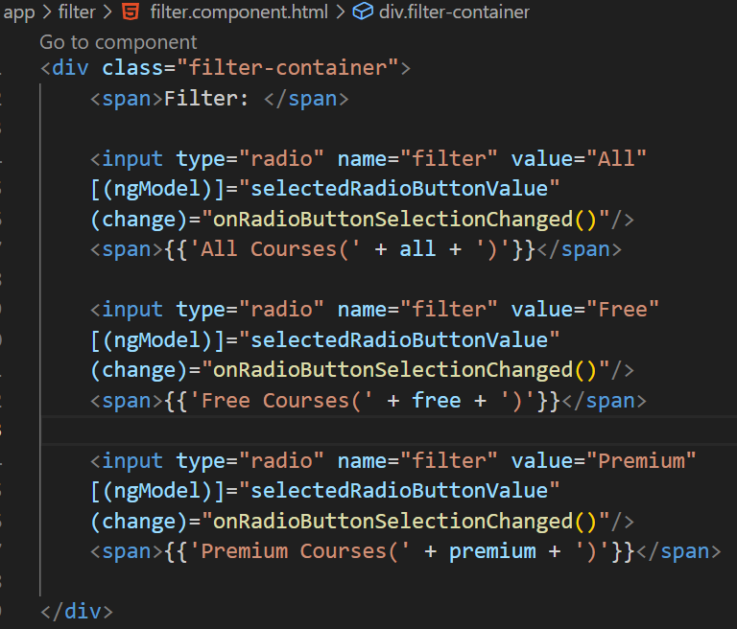

Now we want search functionality for Courses -

In Search child component –

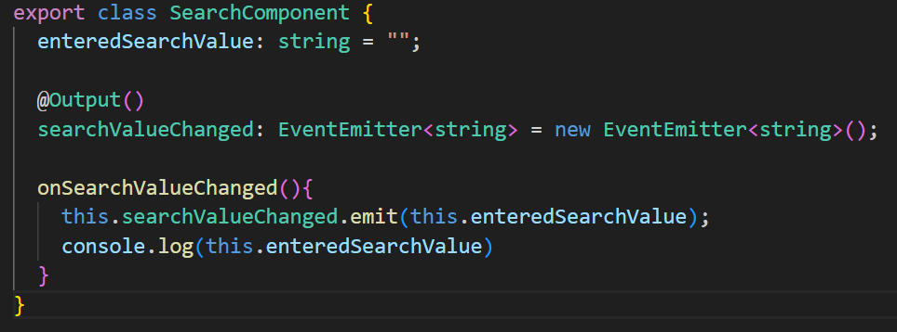

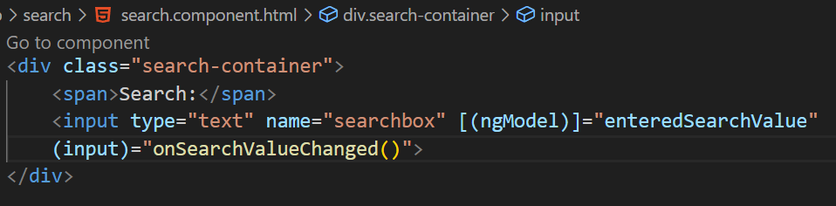

In parent component –

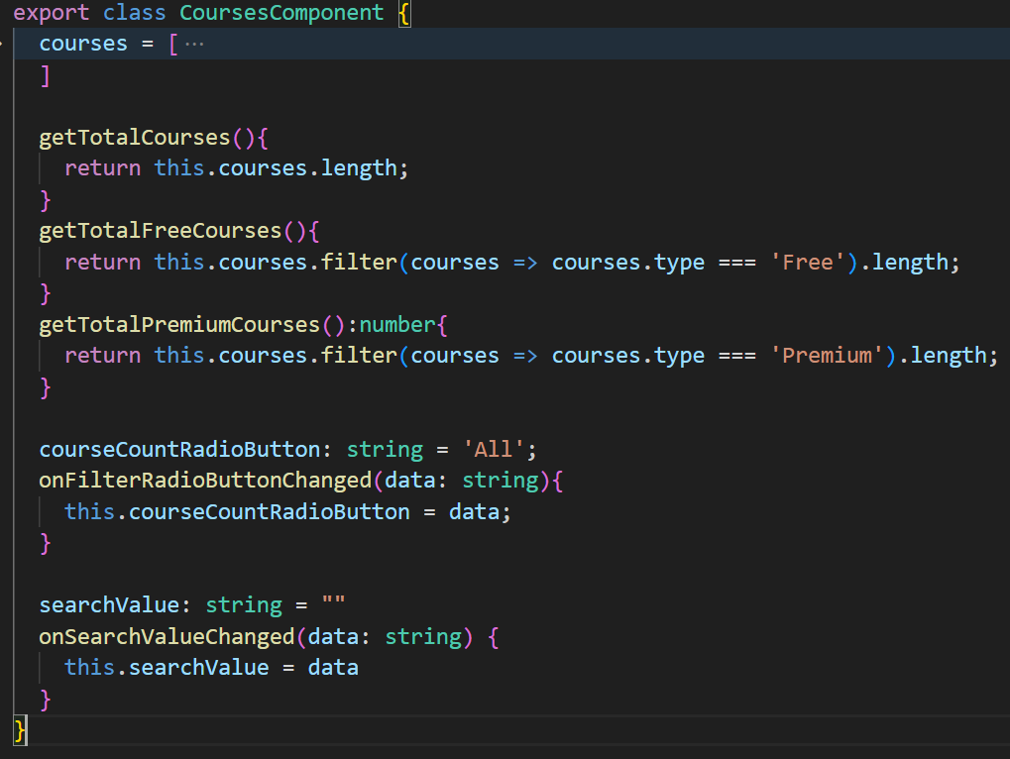

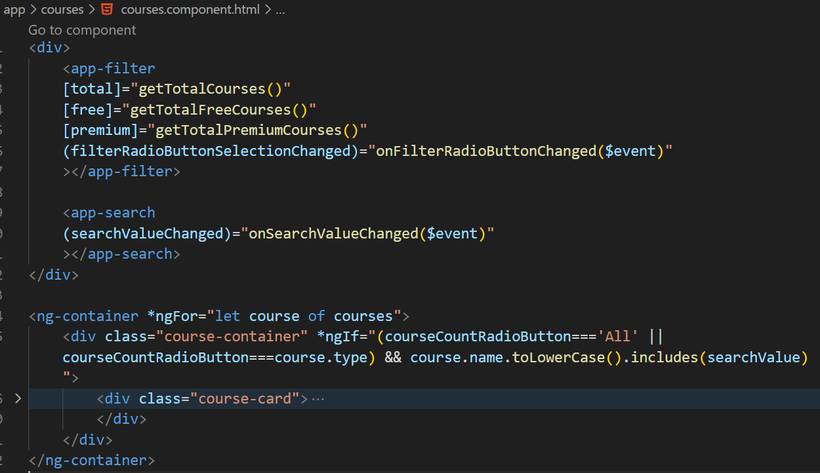

**Note :- We cannot use 2 structural directives (ngFor and ngIf) on same html element and to avoid this we can make use of ng-container directive.**

🡸=============================================================================🡺

* **Template reference variable –**

It stores a reference to an html element, component or directive on which we have used it.

So when html is rendered on web page, in the DOM an object will be created for input element and template reference variable will point to that object in DOM.

Whenever the keyup event is happening, we are not doing anything but since we are handling this keyup event, Angular will run the change detection every time this keyup event happen. And whenever the change detection will run it will update the view.

Ex- 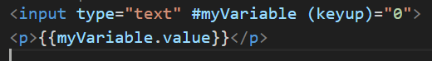

Passing local template reference from view template to component class –

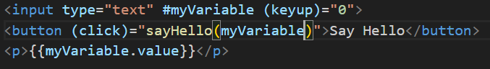

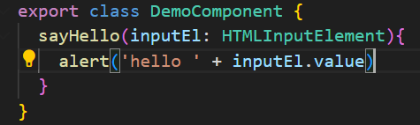

Using Local Reference on Component -

Ex- whenever I click select button that particular customer I want to print in web page.

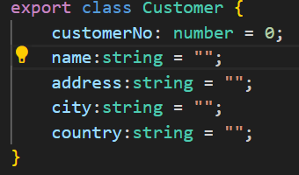 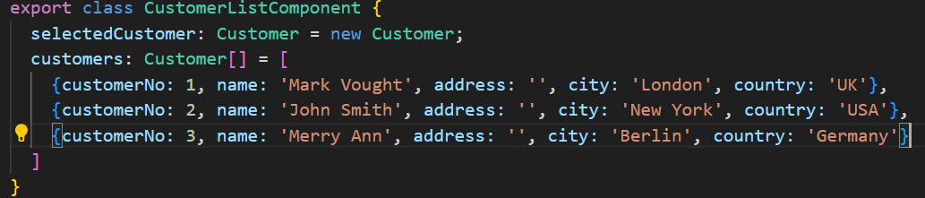

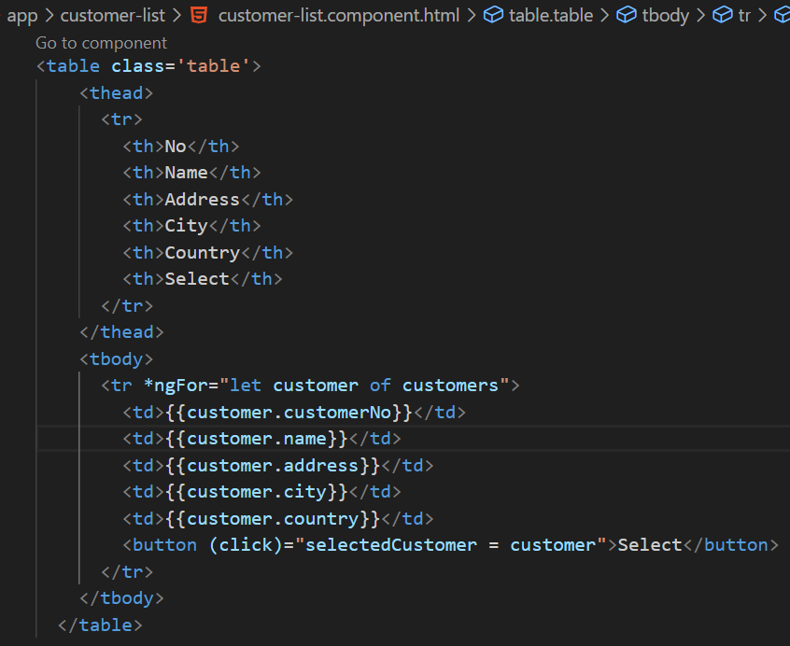

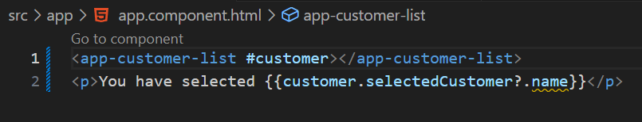

Customer template reference variable points to Customer component.

Note :- ‘?.’ This operator is used to safely access properties or call methods on objects that might be null or undefined. If the left-hand side (object) evaluates to null or undefined, the entire expression (object?.property or object?.method()) evaluates to undefined.

* **@ViewChild –**

Ex- **Access html element from view template in the component class**

Requirement :- based on DOB selected from calender we want to populate the age in text box

We can use a method to pass the html element to the component class by passing the local reference variable to that method as its argument. But sometimes we might want to access the html element before calling a method. For that we can make use of ViewChild decorator.

We want to assign dateOfBirth property as reference to input html element.

* ViewChild decorator assigns a property with a reference to an html or to a component or a directive.
* Blur event occur when focus is removed from that html element and u click outside that element.

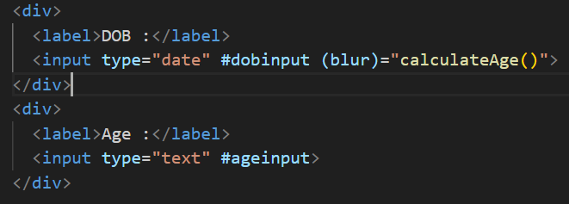

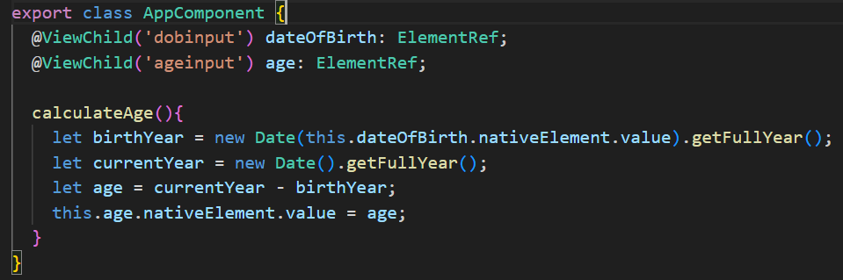

Ex- **Access child component in parent component class**

DemoComponent is child component of AppComponent

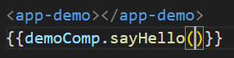

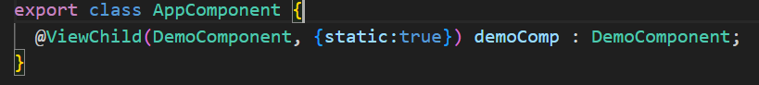

* **View Encapsulation**

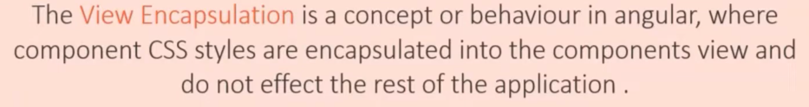CSS styles of parent component will not be applied to its child component mentioned in its view template

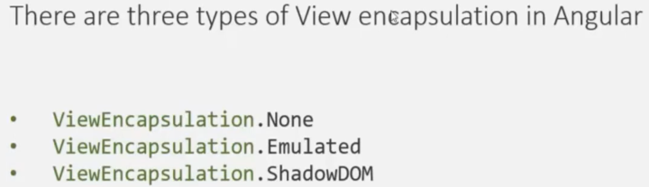

* By default Angular uses **Emulated ViewEncapsulation**. Angular adds some unique html attributes to the component css styles and also to html elements inorder to achieve the view encapsulation.

So **for each component there will be a unique attribute**, which will be added to each html element in that component. Attribute selector is then used to apply CSS

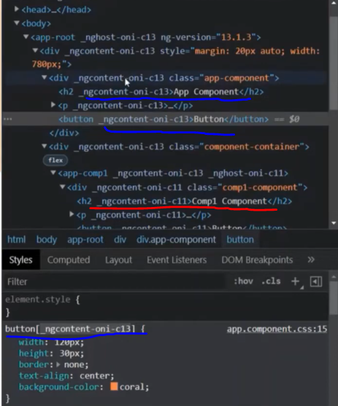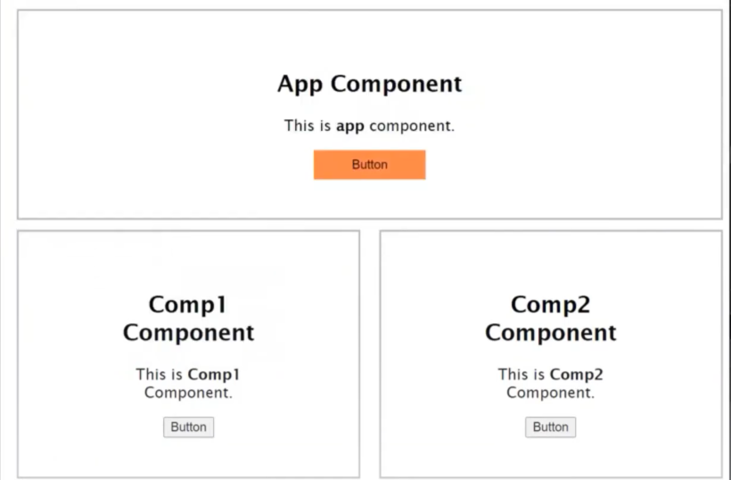

* **ViewEncapsulation.None**

This way no unique attributes will be applied to html elements. Whatever css is applied in parent component will applied to all its child component also.

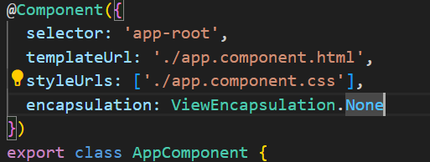

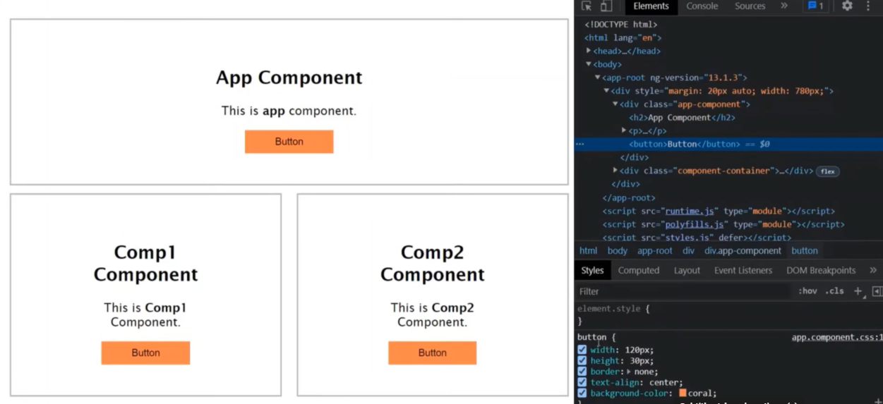

* When we write any css style in style.css file, it gets applied globally.

But when we use **ViewEncapsulation.ShadowDOM** for a component in that case that component creates its own DOM and style.css file is not applied on it. The browser keeps the shadow DOM separate from the main dom and the rendering of shadow dom and main dom happen seperately.

That’s why the feature state and style of shadow dom stay private and it does not get affected by the main dom and in this way we achieve true encapsulation using shadow dom.

* **Ng-content directive**

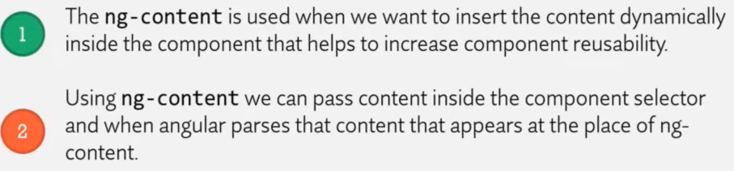

Ex- display newly added products in stock

We can rewrite the title, info, submit button again and again in appComponent but we should make separate component and reuse it.

Inorder to display h4 and button element inside div element of ProductsComponent view template, we need to use ng-content. When html will be rendered in the web page, ng-content will be replaced by h4 and button element for each of the products.

Angular replace the last occurrence of the ng content with the whole actual content which we have specified inside the selector. We can use attribute **select** of **ng-content** to specify theclassof the html element we want to display in place of ng-content.

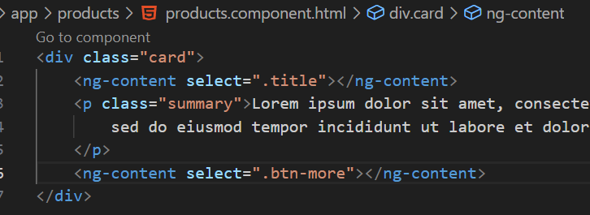 if we don’t use select attribute, then both h4 and button will be replaced by last ng-content.

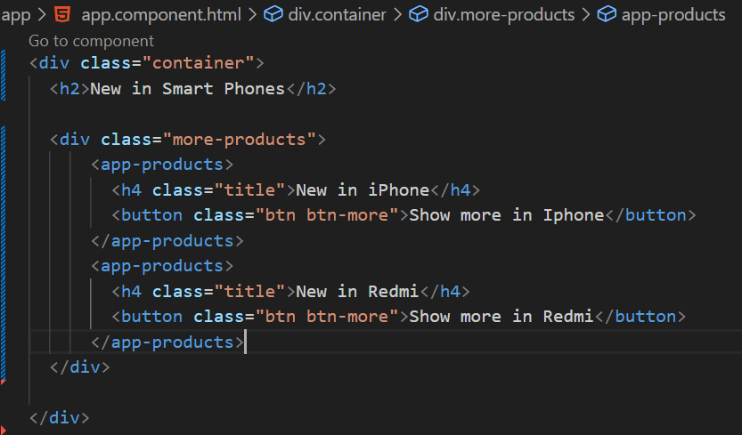

* **Angular Life Cycle Hooks**



When a new component is created in angular and when it finds one of the selectors, it will instantiate the new version of that component and it will add it to the dom.

Ex- 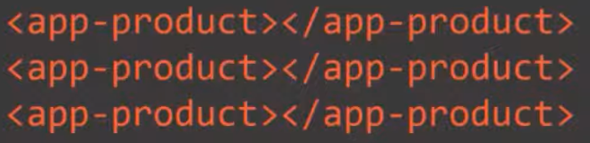 Angular will instantiate product component 3 times.

Once a new component class is instantiated, angular goes through different phases in this creation process. It also gives use chance to hook into these phases and execute some code. We can hook into these phases by implementing some methods which angular will call if they are present in component class and these methods are called as angular life cycle hooks.

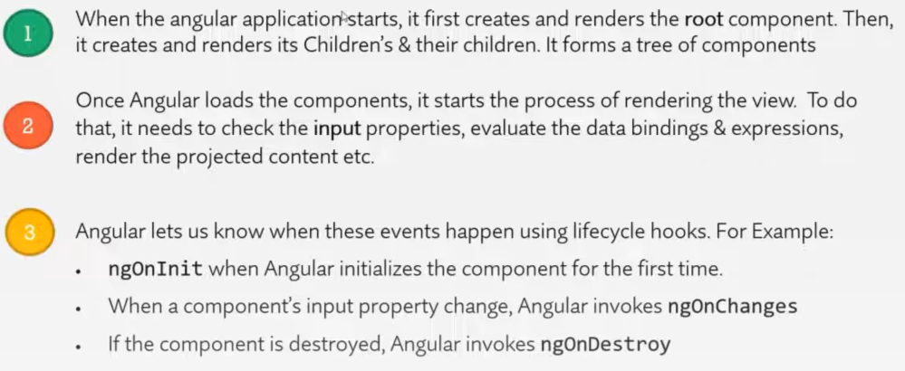

Angular also removes the component from the dom when it is no longer needed.

* **Change detection cycle**

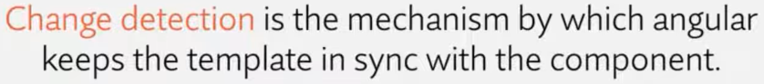

Ex- angular will update the dom every time name property is changed and it does it instantly.

It does so by running a change detection cycle on every event that may result in a change in dom. It runs it on every input change, dom events, timer events, http requests etc. During the change detection cycle angular checks each and every bound property in the template with the component class and if it detects any change it will update the dom.

During this process angular raises the life cycle hooks during the important stages of change detection mechanism.

* 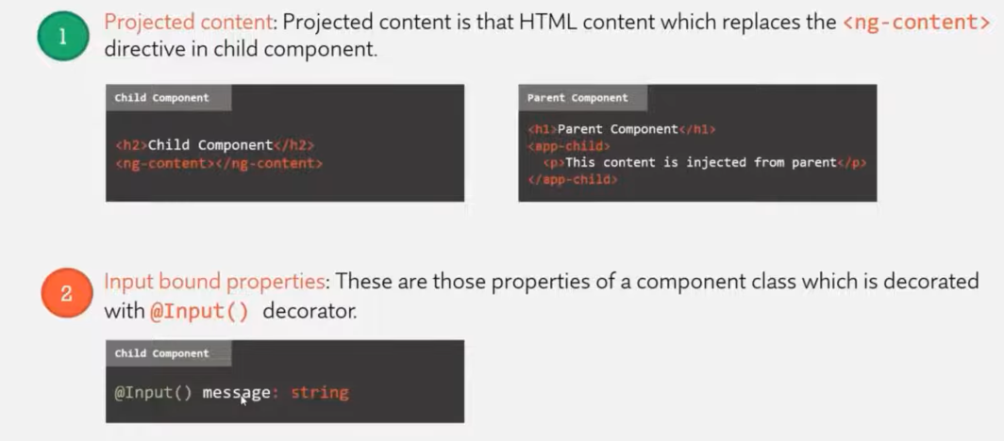
* Angular make use of constructor to inject dependencies

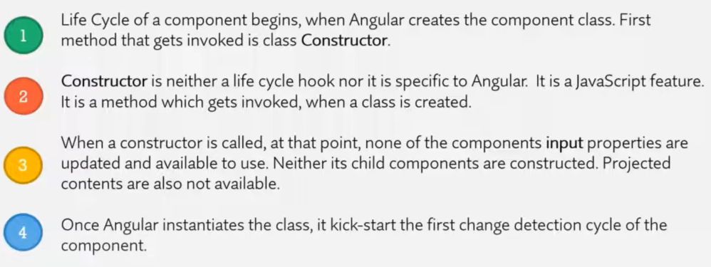

The first hook of a component or directive creation is **ngOnChanges** 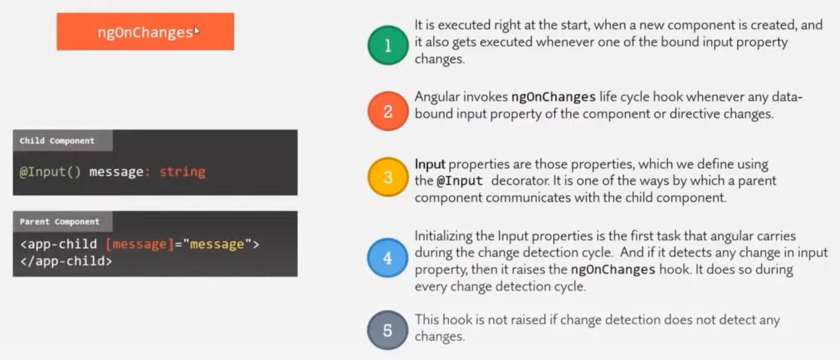

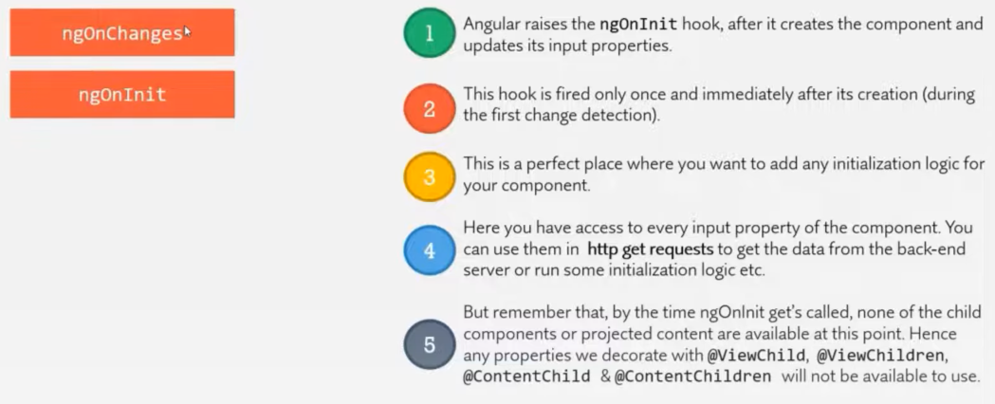

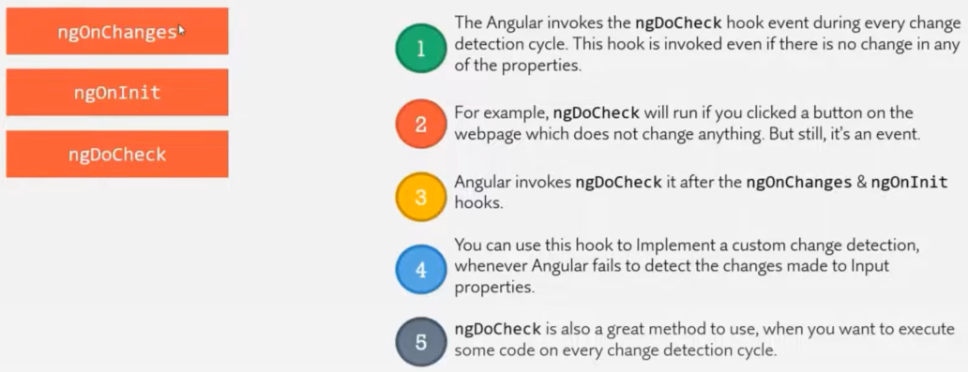

**ngAfterContentInit –** it is called only once during the first change detection cycle. After that if this projected content changes, this life cycle hook will not get called.

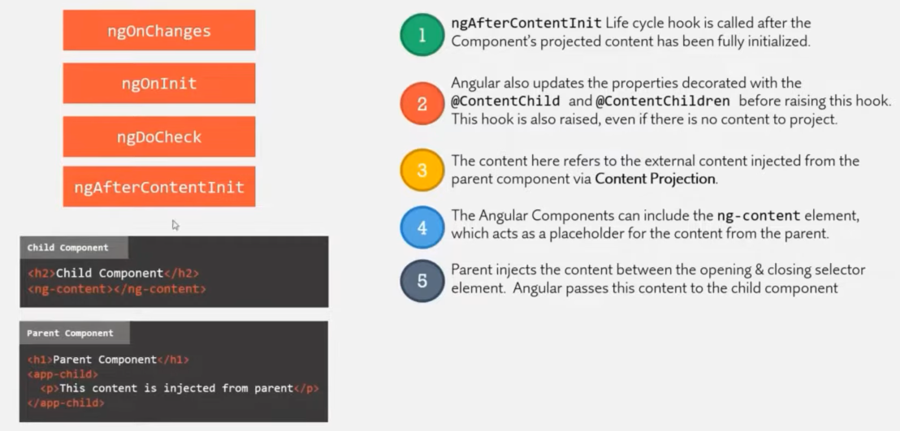

**ngAfterContentChecked –** gets raised during every change detection cycle so whenever there is change in the projected content at that time, it will be raised.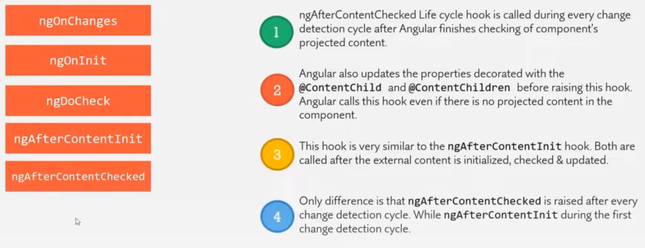

Note : **ngAfterContentInit** and **ngAfterContentChecked** both of them are component only hook and not applicable on directives.

**ngAfterviewInit –** called only once during the first change detection cycle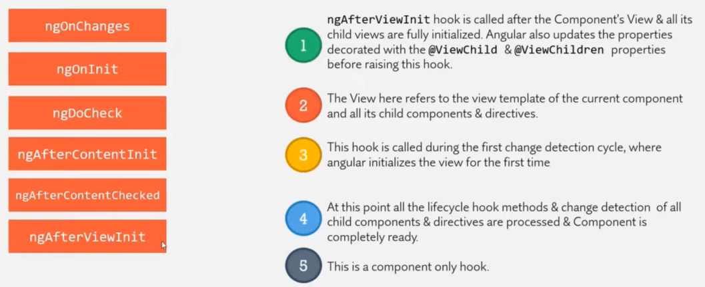

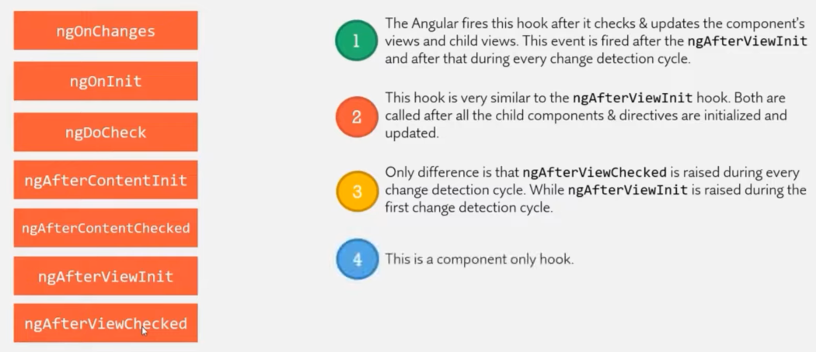

**ngOnDestroy –** called just before the component or directive gets destroyed.

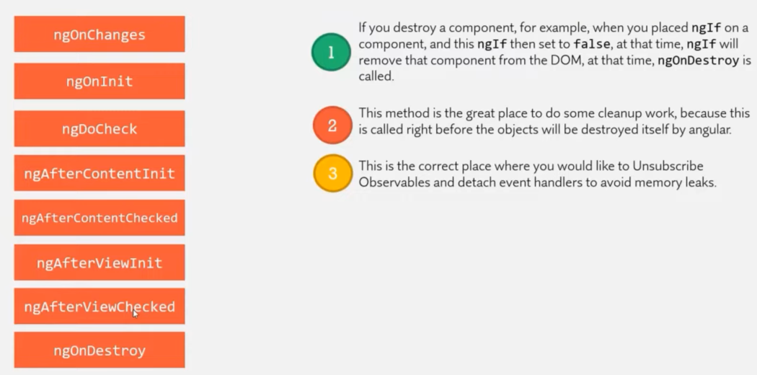

* Ex- There is text input and button in App component, below it we print the Demo component html template which should print the text entered in input which is of App component.

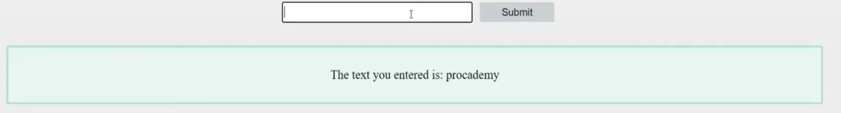

When angular app run, in the app.component.html it will find the selector of DemoComponent so it will instantiate DemoComponent class and first method called is its constructor.

If we use DemoComponent class selector 3 times, then constructor will also be called 3 times.

By the time constructor is called, input property is not updated that’s why it prints proacademy rather than initial inputText = ‘ ’

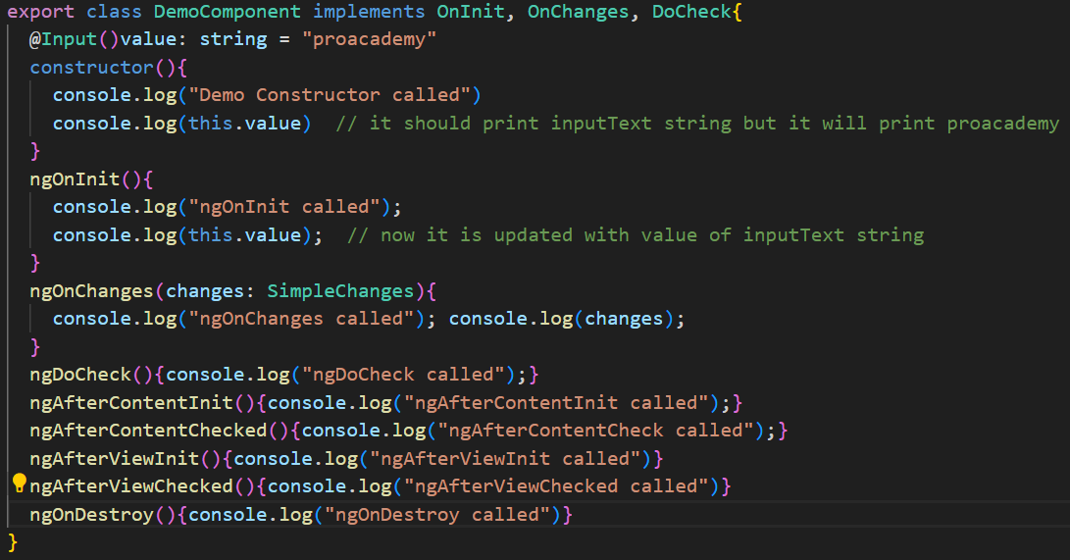

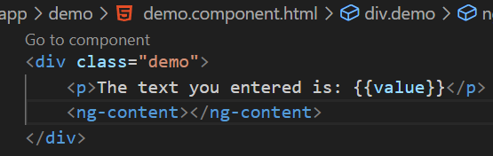

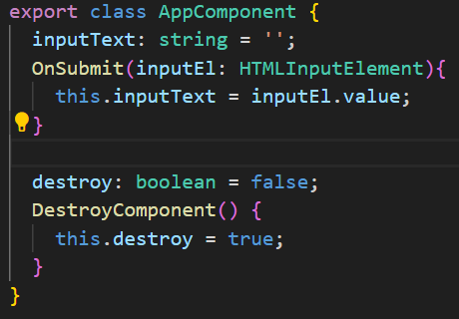

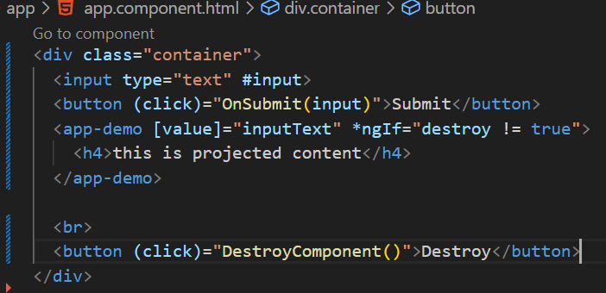

* **@ContentChild decorator**

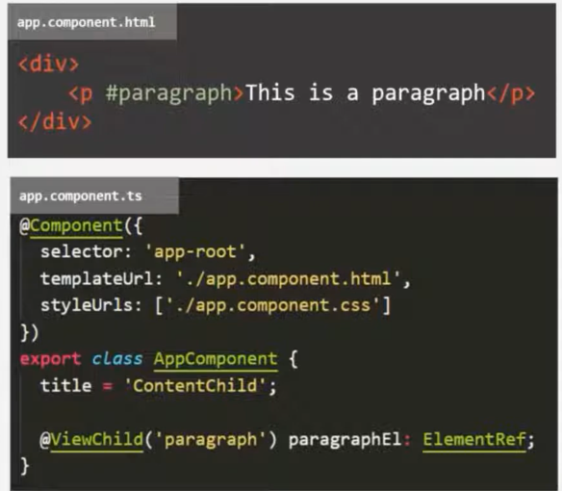We use @ViewChild decorator to access html elements, components, directives from view template in our component class.

Content Projection - 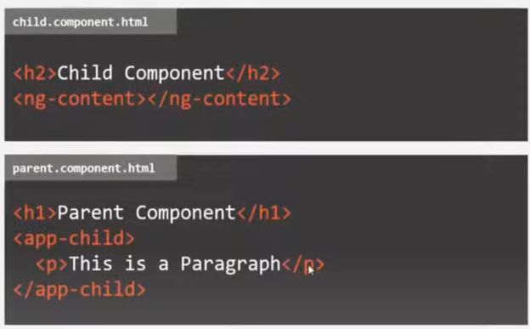

We use **@ContentChild** to access html elements, components or directives from the view template of parent component in the child component class.

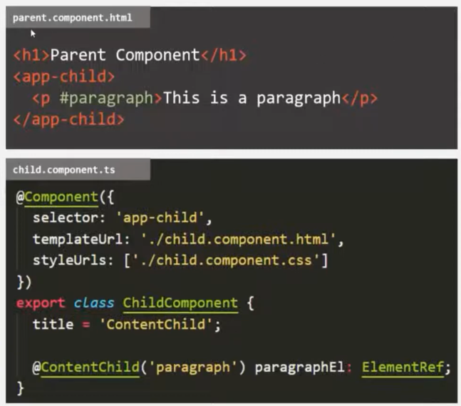

We can also change the element content like this -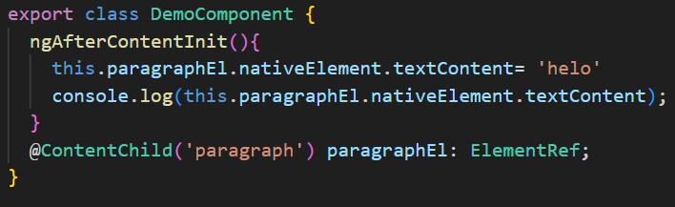

* **Custom Attribute Directive**

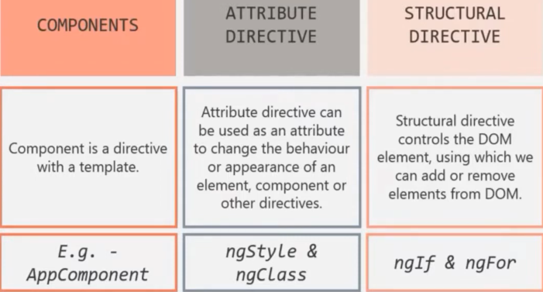

Ex- we want an attribute directive that will change the background color of that html element to green when we use it.

**Value which is assigned to selector propert of @Directive decorator, it will be used as an attribute directive. On which ever html element or component we’ll use this directive, that html element or component will be pass to constructor of our custom directive.**

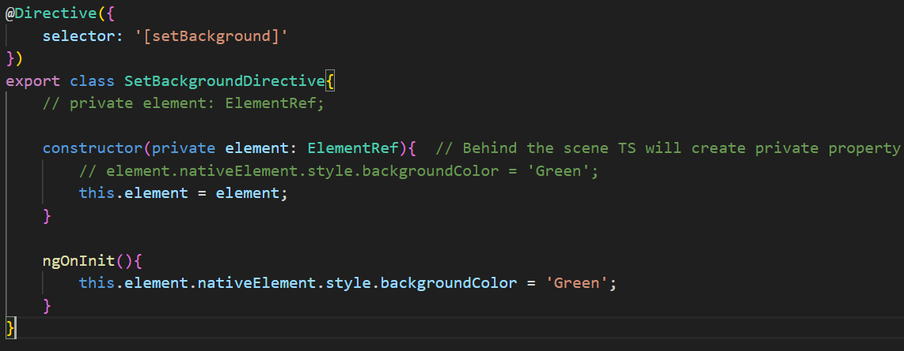

Register this class inside app.module.ts in declarations:[ ]

Writing logic in constructor is not good, so write it in ngOnInit which is called just after directive is initialised. If we don’t write private (private element: ElementRef) inside constructor then we would have to declare private property explicity. (see commented line above constructor)

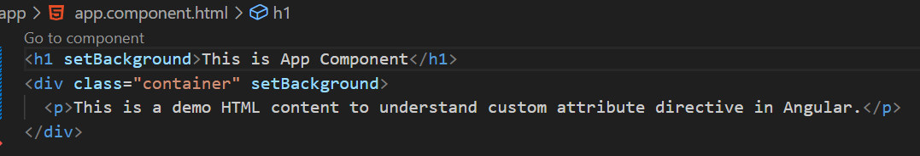

* **Renderer2 in Angular**

We are using nativeElement property of element ref to manipulate the dom.

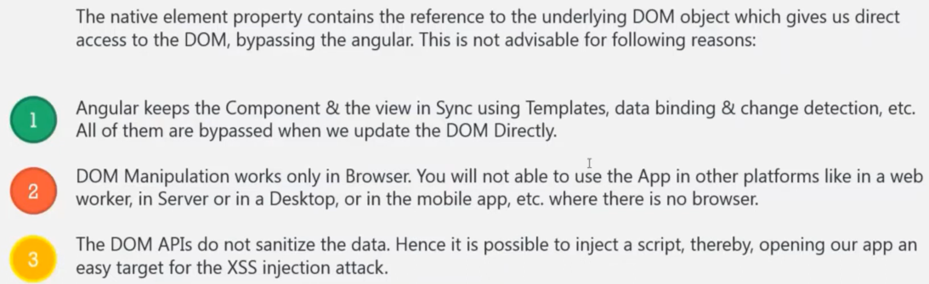

Renderer allow use to manipulate dom without accessing the dom object directly. It provides a layer of abstraction between the dom element and the component code. It provides various method to set css style, add css class or we can also set some attribute for html element.

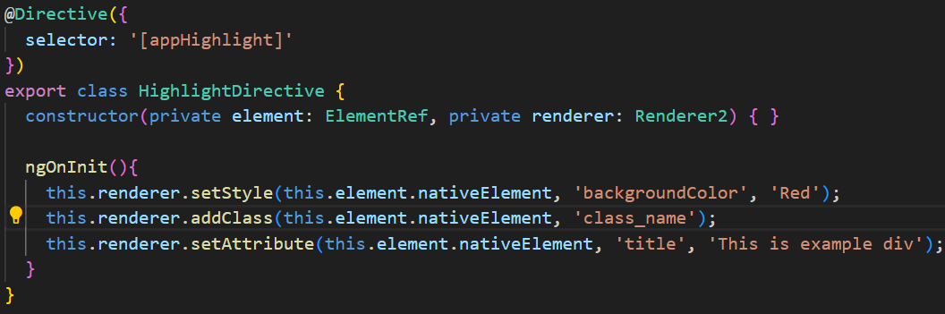

* **@HostListner**



Ex- whenever user hover over div, we want to set margin and padding

To tell angular that when the mouse hover event will happen on the host element, we want to execute this event handler method we can make use of host listner directive.

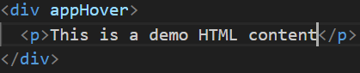

‘mouseenter’ and ‘mouseleave’ are event names

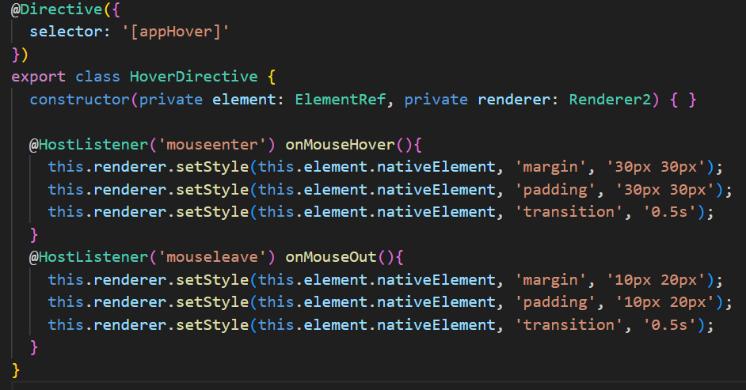

* **@HostBinding**



Using it we are binding the property of directive class to the property of the html element

To @HostBinding decorator we can specify a html property.

Ex- We want to assign “**background** property of BetterHighlight directive class” to the “**style.background** property of html element”. Also we want to set bakground color to red whenever mouse hover over it and change background back to transparent when mouse leave event happen.

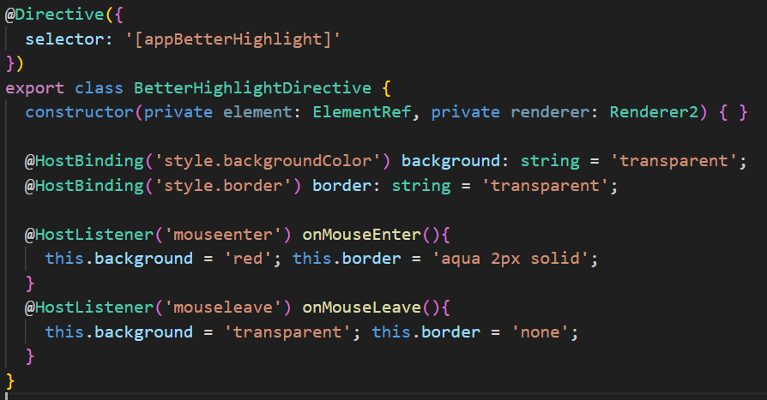

* **Custom Property Binding on Directives**

For using custom binding, we decorate the properties with @Input decorator.

Ex- In above example of BetterHighlightDirective we are hardcoding color values but our requirement is we should be able to set the value of background color from out component.

We can provide an alias for main property of directive(or when we have single property) and that alias is the selector name for that directive and then we are using that selector just like we use ngStyle or ngClass (attribute directive) ex- [ngStyle] = “ “

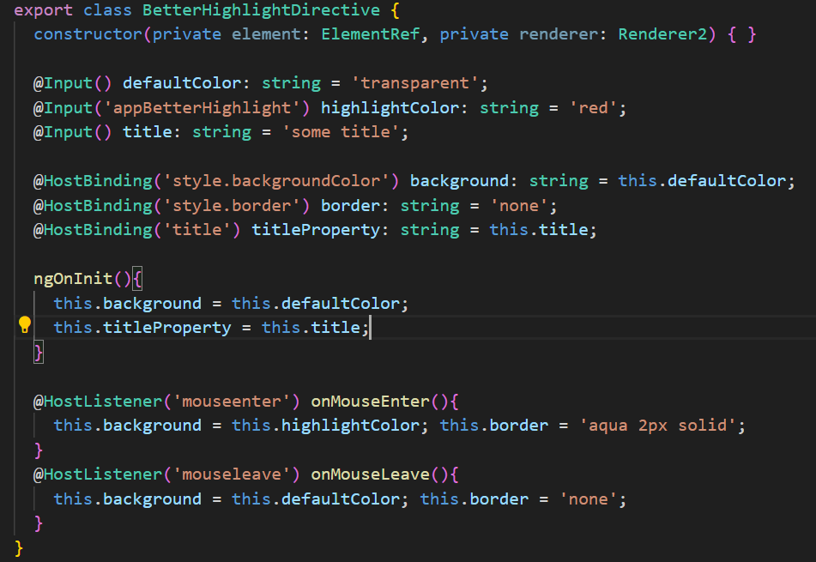

If using alias, second way is used. Otherwise without alias, use first way.

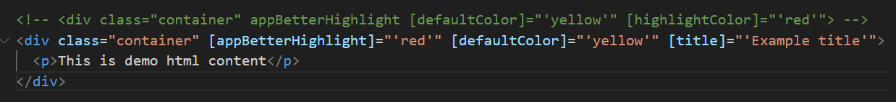

When we bind title property of directive on host element, how does angular know whether I should use title property of div element or the title property of the directive?

Ans :- Angular will first check that property in custom directive and it does not find the property in custom directive then it will look for the native property of host element.

* **Custom ngClass Directive**

When we use appClass selector on any html element or component we are going to assign an object to this directive and we want to receive this object in ClassDirective class.

**Set allows us to use a property like a method.** And then we can write some logic to set the value of that property.

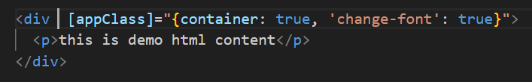

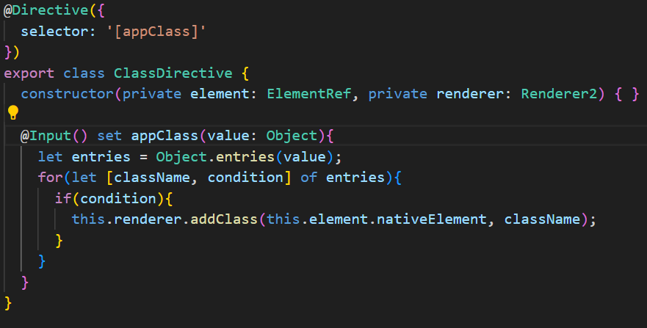

Here the property name we take appClass is same as the selector, so now we can directly use [appClass] = “ “

Otherwise we can also give alias ‘appClass’ to the property. Ex- Input(‘appClass’) set display(value: Object){ } and then use [appClass] = “ “

* **Conditional Directive**

Ex- suppose we have a list of cards and only want to highlight which have highest number of likes

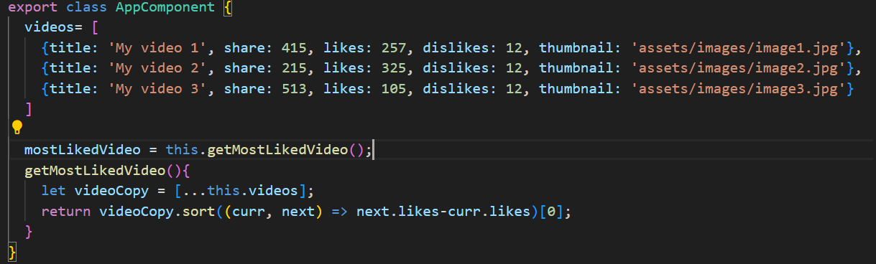

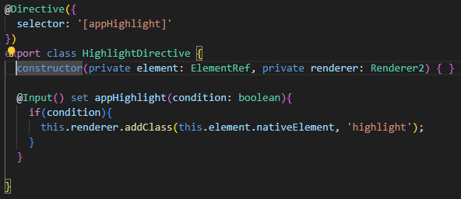

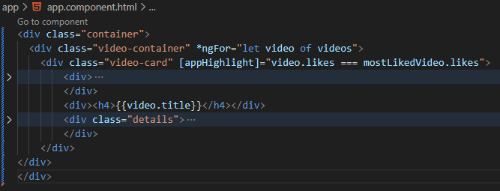

* **Custom ngStyle directive**

This app style directive will set a css style for an html element on which we’ll use this app style directive.

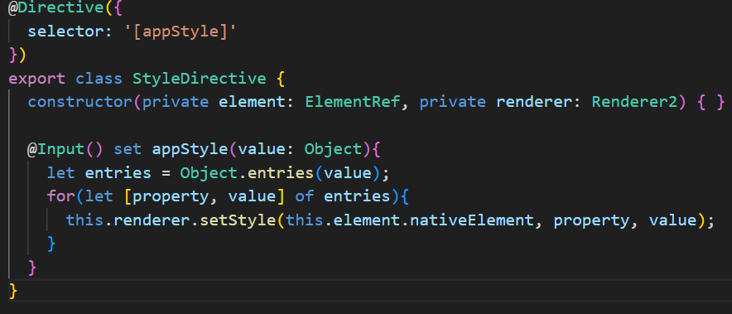

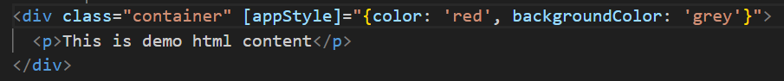

* **How Structural Directive works?**



When we use asterisk before a directive name, this * tells angular the angular that this is a structural directive. Behind the scene angular creates a template some thing like <ng-template> </ng-template> and then it wraps the view of that structural directive inside this template.

And it will also move this ngIf directive from this div element to this ng-template and here * will not be used. And that structural directive will be used like any other attribute directive by wrapping it within square backets [ngIf]

Ex- show notice only when use click on show notice button

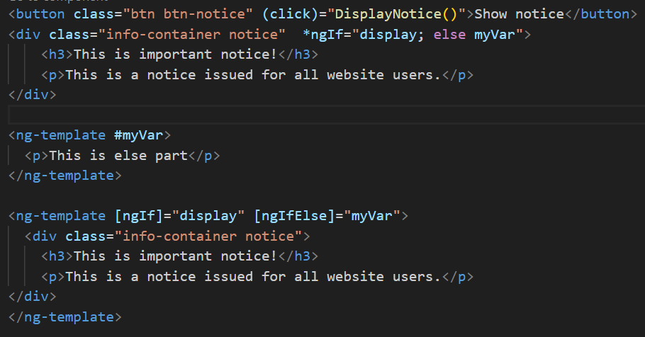

* **Custom Structural Directive**

In order to make custom structural directive, we need two things – what to remove and from where to remove?

When we use attribute direcrive on an html element then in constructor of that directive we get a reference to that element and we need that reference in case of structural directive as well. We also need the container inside which that view is present.

In constructor, the template is the view on which we have used our structural directive like the <div>. ViewContainer is the container inside which the view will be added or remove like <ng-template>

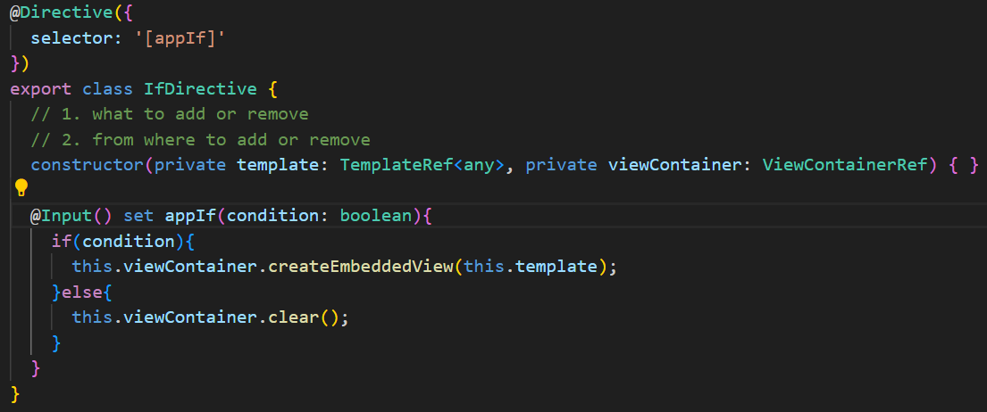

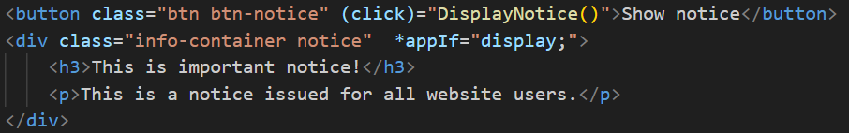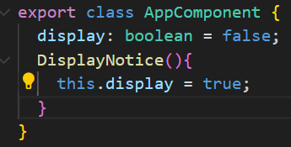

* **ngSwitch directive –** it’s a structural directive but we don’t use * before it rather we wrap it in square bracket because ngSwitch is not going to manipulate the dom, it is simply going to check the expression.
* **ngSwitchCase** is the directive which is going to manipulate the dom

Ex- out of multiple paragraph display only one at a time based on a Ts expression.

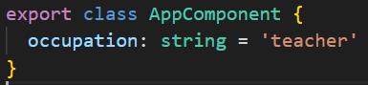

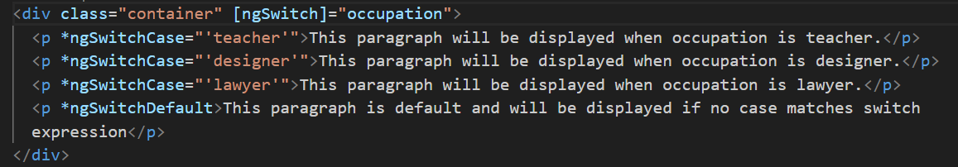

* **Services**



Why we need service?

Lets say we have several components in app that need to access some data. We can write data access code in each component but this approach is very inefficient and it breaks the rule of single responsibility. Your component should only focus on presenting the data to the user and the task of getting data from the backend server must be dedicated to some other class and we call such a class a service class.

Ex- here we r repeating the same code in 3 different components. It will be good if we write this method in a centralized file and then we can access that file to use this method for each of the component.

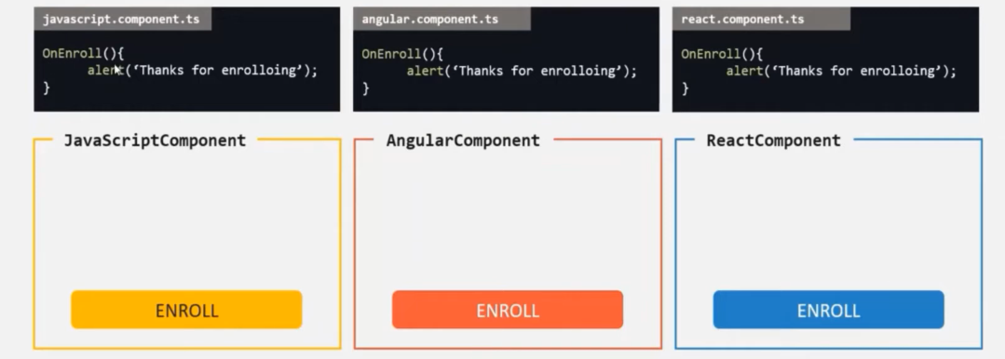

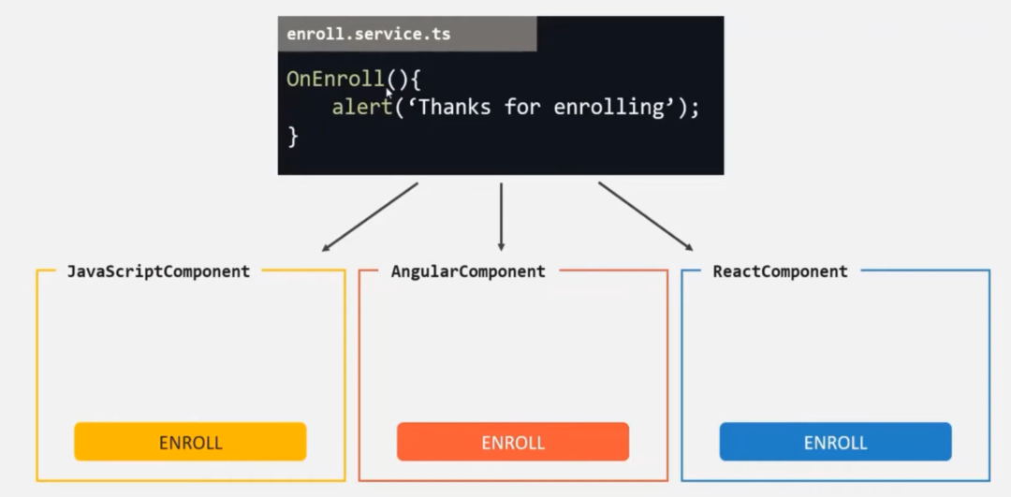

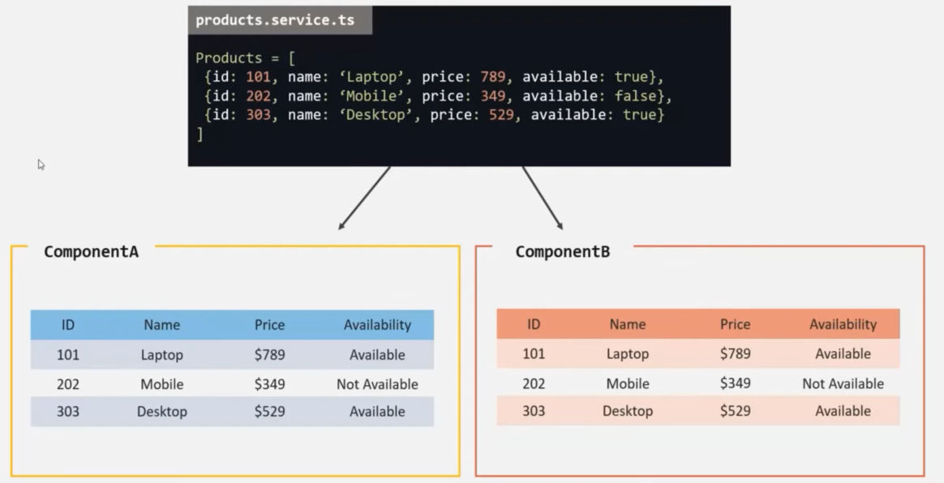

Ex- we want to communicate between 2 components which don’t have parent child relationship

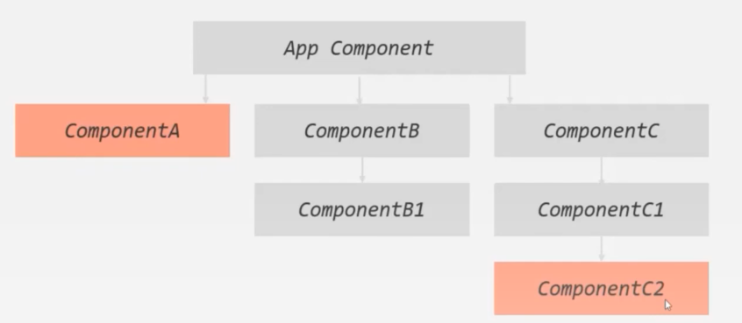

Advantages of Services – 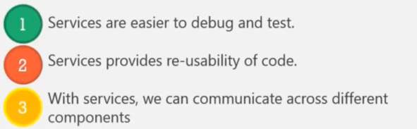

Note :- **we don’t need to decorate service class with any decorator**

Ex- we want when user click on enroll button, it gets alert message “thank you for enrolling to javascript course” and same for angular course button.

We can ask angular to provide us an instance of this EnrollService class by using dependency injection.

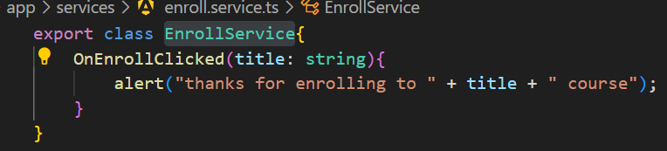

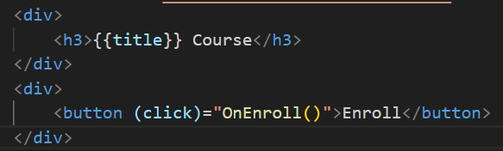

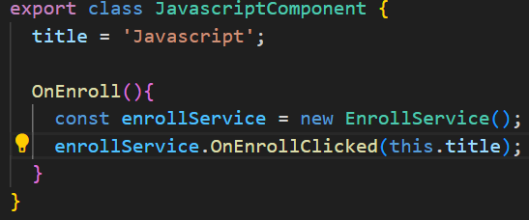

* **Dependency Injection**



In **providers property** of Component decorator we assign an array and inside this array we specify the type which we want as a dependency. This can create a single instance of service for the component and its child components. This way we don’t need to explicitly create new object of enrollService like we did in previous example.

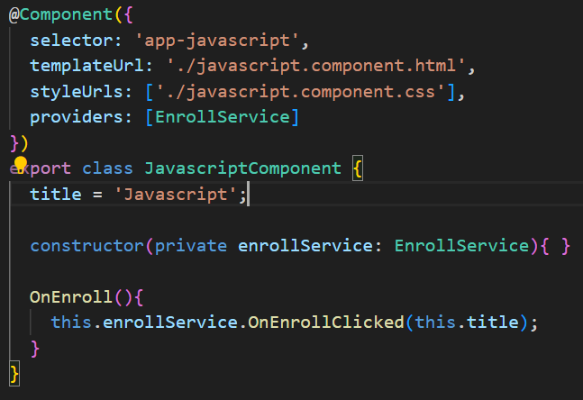

* **Hierarchical Injection :** Angular dependency injector is a heirarchical injector. 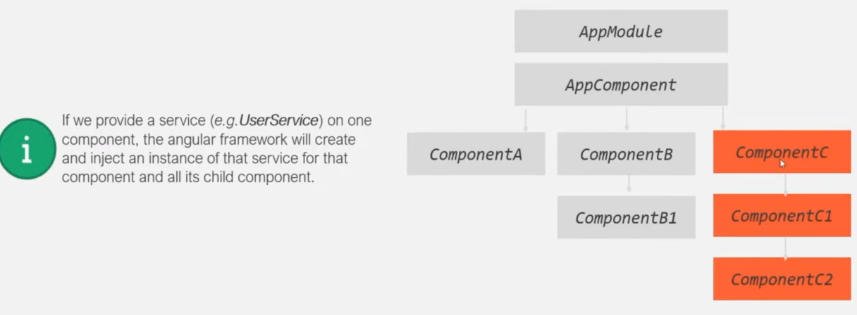The highest possible level where we can provide a service is the app module. If we provide a service at app module level then the same instance of the service is available throughout the app in all the components, directives and all other services where we may inject this service.

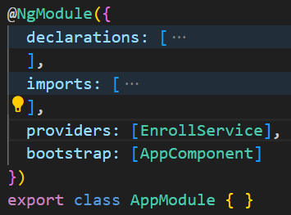

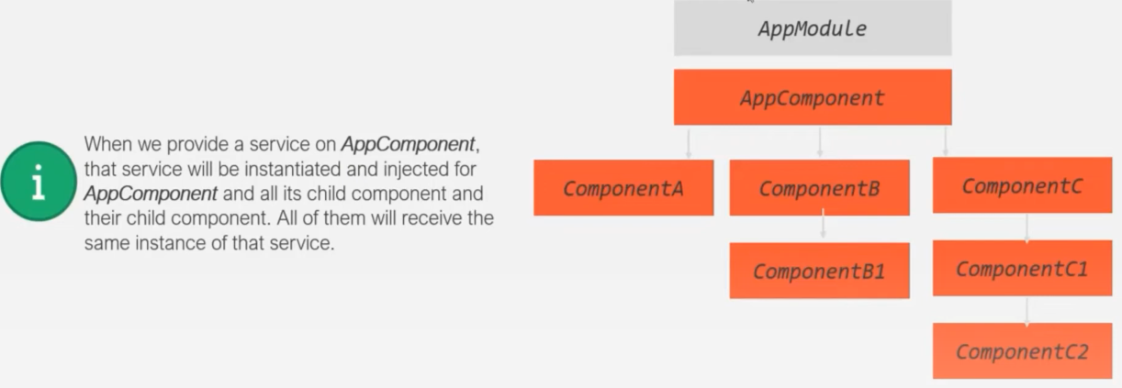

Dependency injection does not work in upward lvl only downward.

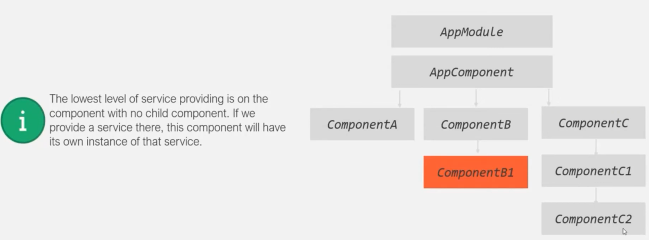

Note :- lets say in app module we are providing this Enroll service and then we also provide a service at appComponent level, in this case again a instance for app module will be created and it will override the instance of the enroll service created by app module. So now that instance will be propagated throughout the child components of this app component.

Similarly the instance created by child component can override the instance created by app component and also override the instance created by app module.

* **Creating Data Service**

Ex – we want to display all three user on web page

although we are adding new users from the UI but ngFor in app.component.html is not adding this user in users property of UserService, We are only seeing 3 users in webpage.

**Reason is** : in app component we are creating an instance of this user service as we are specifying the providers array and we are looping over that instance. But in the addUser component we are again providing this userService so here angular will inject a new instance.

And when we are adding new user using code given in addUser.component.html then it is added for userService instance of addUser component class.

Both userService instance in app component and in adduser component is different as adduser is child component of app component.

To remove this bug, remove userService in providers array of child component. **When we specify a provider on a component the same instance gets injected for that component and its child components.**

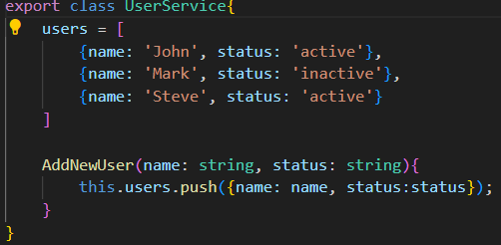

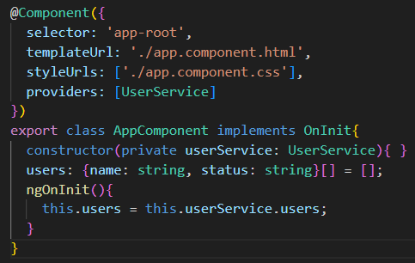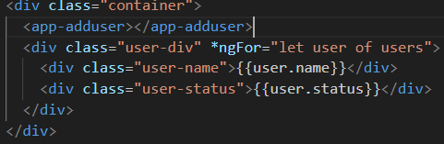

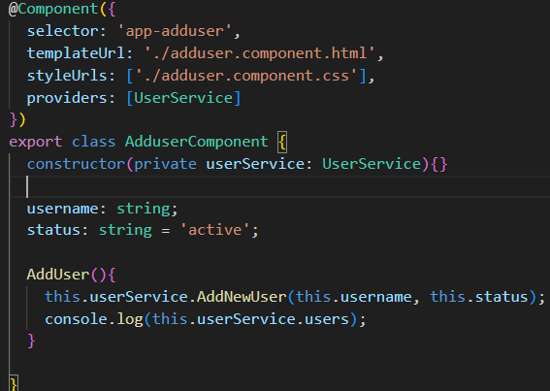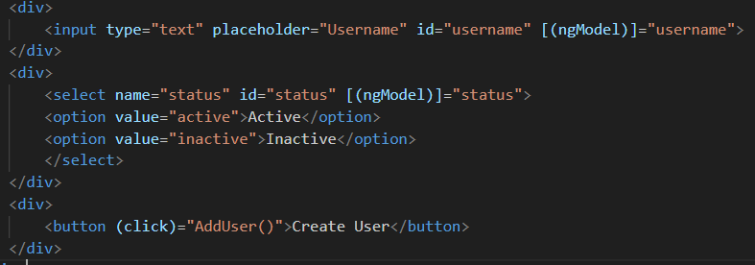

* **Inject Service into another Service**

When we inject a service into something, that something needs to have meta data attached to it. Like a component have some meta data which is specified in @Component decorator.

But a service does not have any metadata and in Angular we need to attach some metadata to the class where we want to inject something and we cannot attach any metadata to a service. For that we have a special metadata for services and that is **@Injectable**

**We use @Injectable on the receiving service.** In newer versions of Angular its recommended to use it on each service.

@Injectable({ providedIn: 'root' })

providedIn :'root' creates one instance to the whole application without the need to provide it from any NgModule

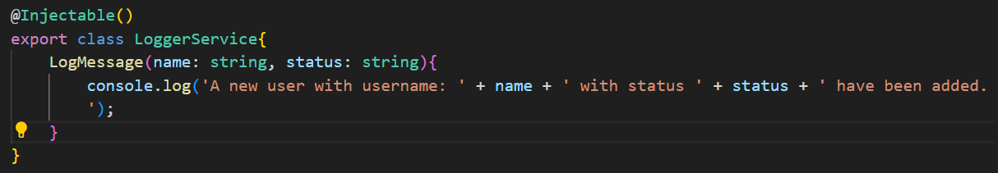

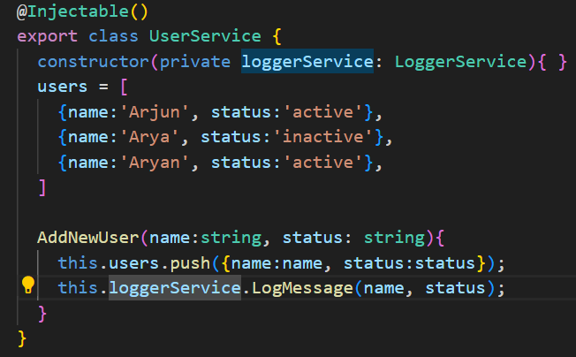

* **Component Interaction with Services**

Ex- we’ll make alluser component and showdetail component. Both are unrelated. We want when user clicks on Show Details button of adduser component, we want to diplay the complete detail of that user in user detail component

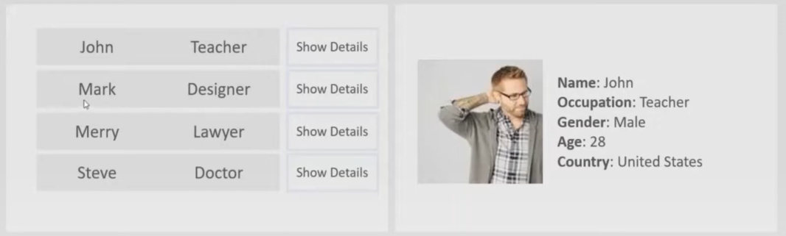

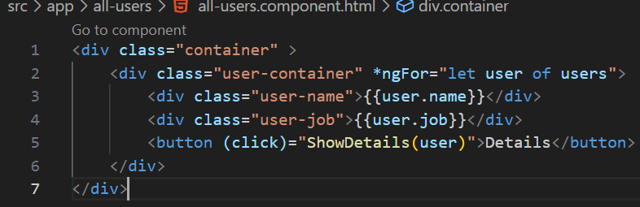

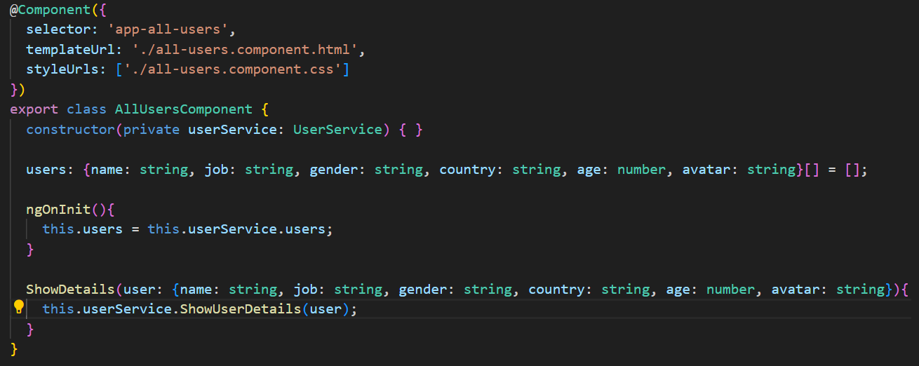

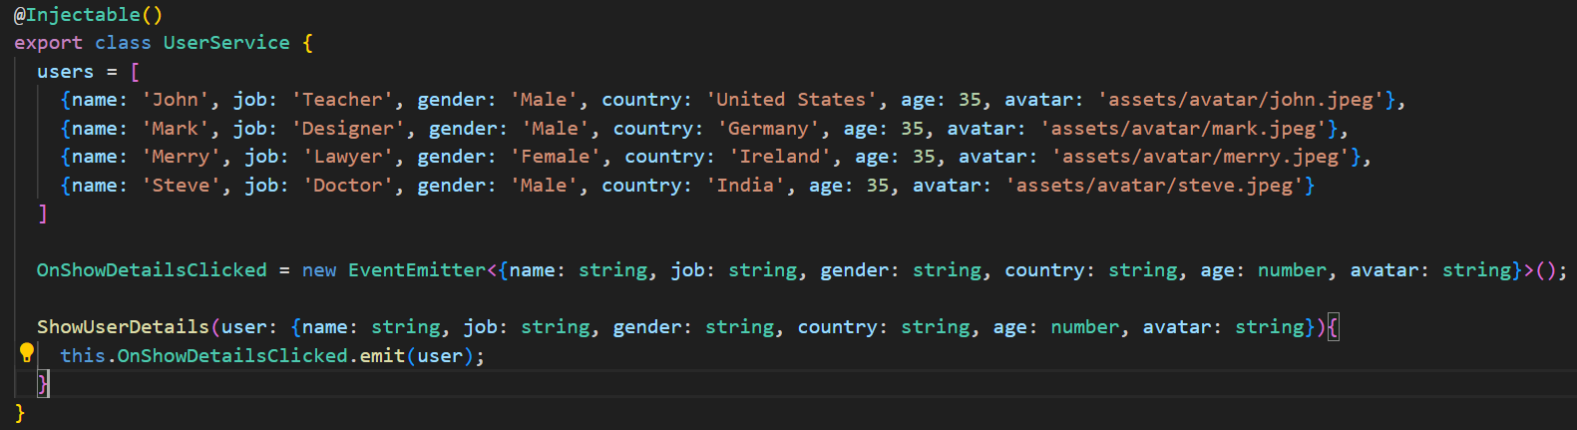event will return an observable and we susbscribe to it and pass a callback fn.

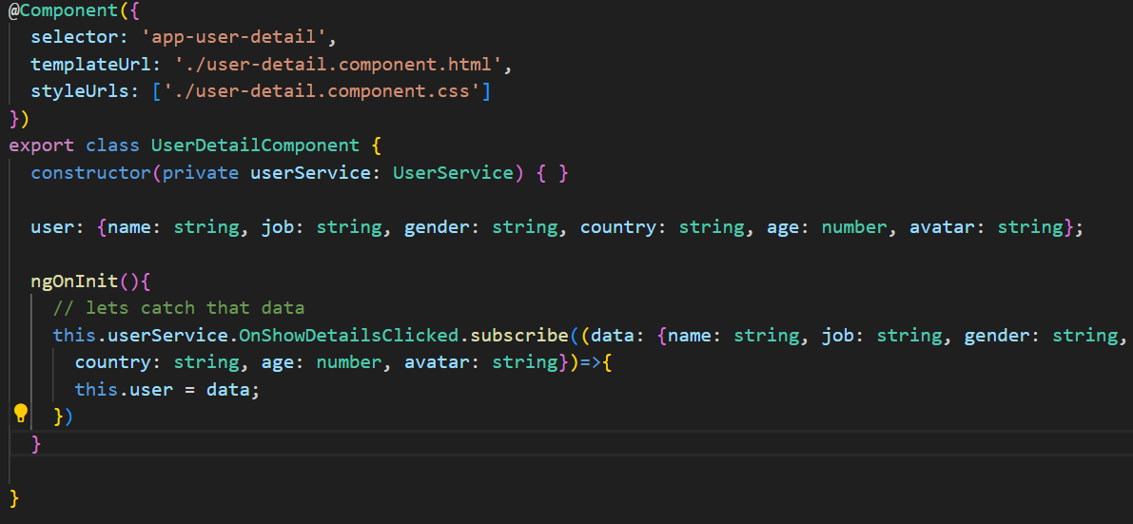

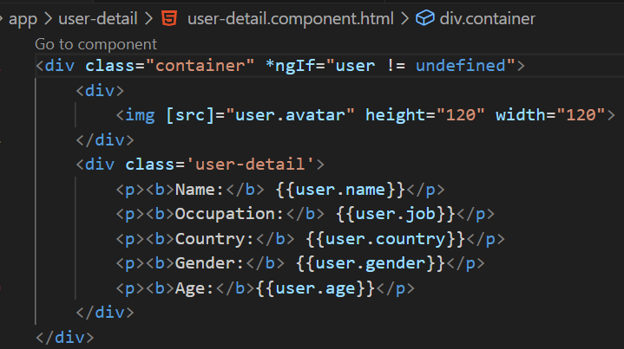

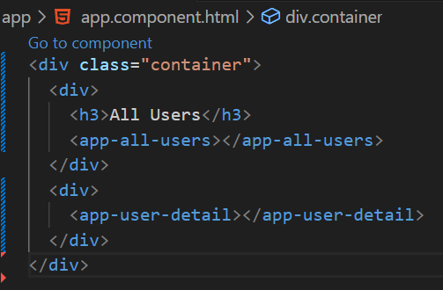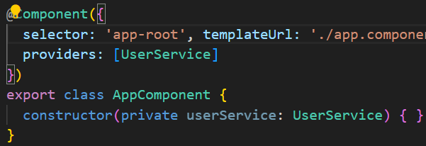

* **Observables**



Another way of doing same thing is using promises. JS is a single threaded programming language which means the code is executed line by line and once the exceution of one code is complete then only the next code in the program will be executed.

So if a task takes long time in its execution lets say we are making an http req to the server, in that case it is going to take some time. So all next statements will have to wait for its execution, it only gets executed when the http request completes. We can say that the synchronous code is blocking in nature. Asynchronous code runs in background without blocking the execution of the code in the main thread.

Ex- we are creating a app which needs some data from the server. The data which we are requesting is huge so server will take some time to gather all the data. Once that data is available it create a response and will send that data at once with the response to the client.

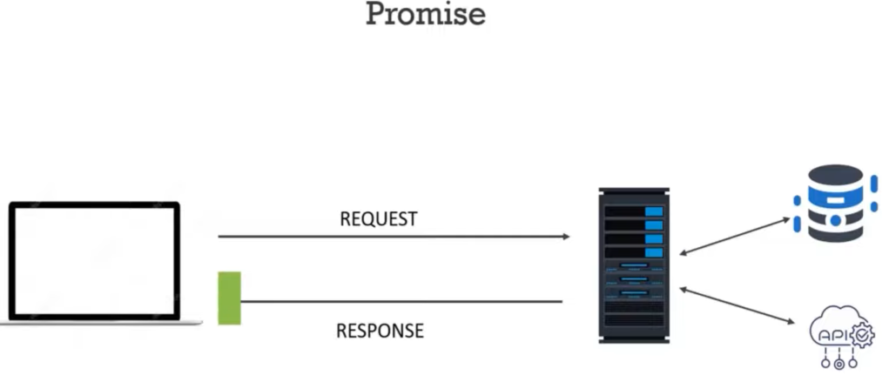 This is how a promise works.

A promise promises us some data and provides us the data over a period of time. Promise provides us the data once the complete data is ready. The data can be the actual data we requested for or it can also be an error object.

**How an Observable deals with asynchronous data –**

Observable will not wait for the complete data to be available, an observable streams the data so it will send the data in packets. When some of the data which is available it will send it and again get the rest of the data and it will send it with the response. It is not waiting for all the data to be available and send at once.

**Difference :-**

1. The promise returns us all the data at once it provide us a single data but an observable streams the data, it provides us multiple values.
2. A promise will certainly give u some data even if there is not code using that data but in case of an observable it will only provide the data if there is someone to use that data. If there is no one to use that data, observable will not send it.
3. A promise is native to JS but observable is not native, it is provided by another JS library which rxjs





RxJs has 2 players – the **observable** which is the stream of data and the **observer** which is going to use that data.

Now inorder to make this Observer use the data emitted by this observable, the observer has to subscribe to that observable. => **Observer is the subscriber of that observable**.

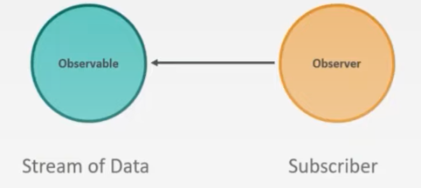

Implementation –

To the observable constructor we need to paas a callback function. This callback fn will receive an argument the **observer** and this argument will be injected by rxjs library. This observer is the subscriber which is waiting for the data. Next() method is used to emit some data on this observer.

This observable will only emit data if there is some subscriber.

Subscribe(next, error, complete) method takes 3 optional parameters –and these parameters are callback fns. Next parameter is a callback fn which gets executed every time Next() method is called in Observable callback fn.

In this example where we are subscribing to myObservable and next callback fn will be called 5 times because this observable is going to emit 5 data. This callback fn receive the data which the observable has returned or emitted. (val parameter)

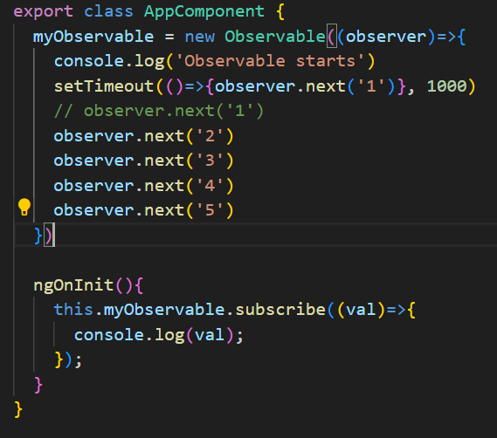

Once an observable returns an error after that it is not going to emit any other value or the complete signal. error parameter in callback fn will be assigned to error object which is emitted.

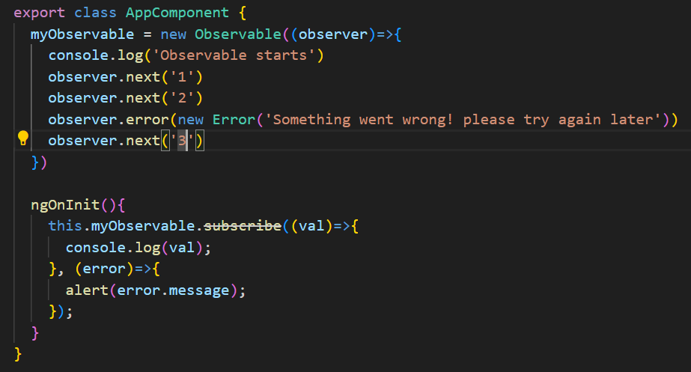

Once the complete signal is emitted from the observable after that if we have any data to be emitted, that will not get emitted.

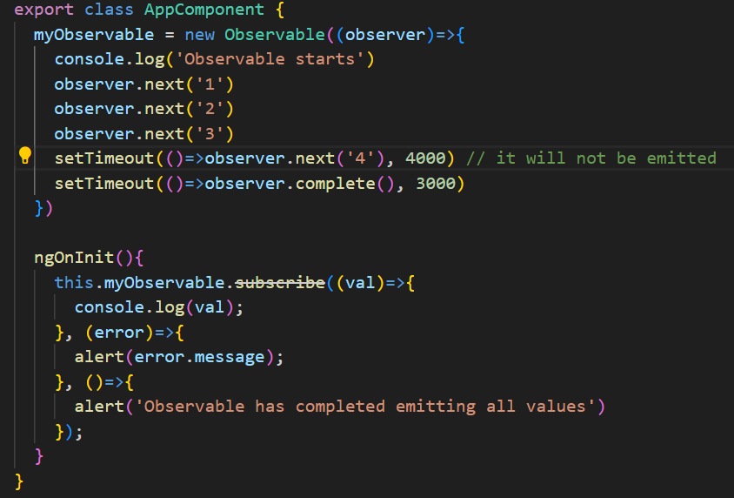

**Different ways of creating an Observable -**

1. Using of() operator :- to this of() operator we can pass any number of arguments and those arguments will be emitted as the data from that observable.

Ex- array1 and array2 is emitted by this observable and after that this of() operator has also emitted a complete signal. For this of() operator we don’t have to explicitly emit the complete signal. Of() operator will emit the complete signal after it is done emitting all the data.

Of() operator will emit the arrays as it is. It is not emitting each value of this array one by one.

1. From() oprator :- To this from() operator we can pass any iterable like array or string. For() operator iterates over the iterable and then it emits the values of that iterable one by one.

From() operator can take only 1 argument and that also should be an iterable.

To this from method we can also pass a promise to convert that promise to an observable.